**Geometry Section 3.1 – Parallel Lines Name: _________________**

Identify each pair of angles as vertical angles, corresponding angles, alternate interior angles, alternate exterior angles, same-side interior angles, same-side exterior angles, or a linear pair. Then determine if the angle pairs are congruent to each other or supplementary

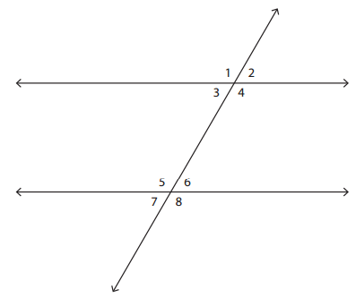

|  |  |  |
| --- | --- | --- |
| **Angle pair** | **Type of angles** | **Congruent or Supplementary** |
| 1 and 5 |  |  |
| 3 and 5 |  |  |
| 2 and 4 |  |  |
| 8 and 1 |  |  |
| 6 and 7 |  |  |
| 5 and 6 |  |  |
| 1 and 7 |  |  |
| 6 and 3 |  |  |
| 4 and 6 |  |  |
| 5 and 8 |  |  |