**H. Geometry Classifying Triangles #1**

**Put a check mark in EACH box that describes the given triangle.**

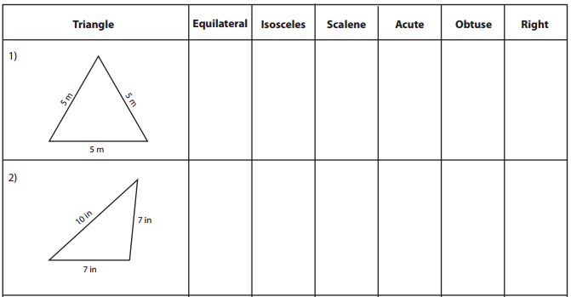

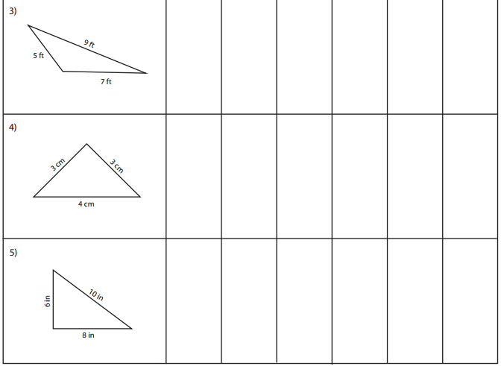

**Put a check mark in EACH box that describes the given triangle.**

