**H. Geometry Section 3.1 Cont. 2 – Properties Parallel Lines Date: _____**

You can display the steps that prove a theorem in a two-column proof.

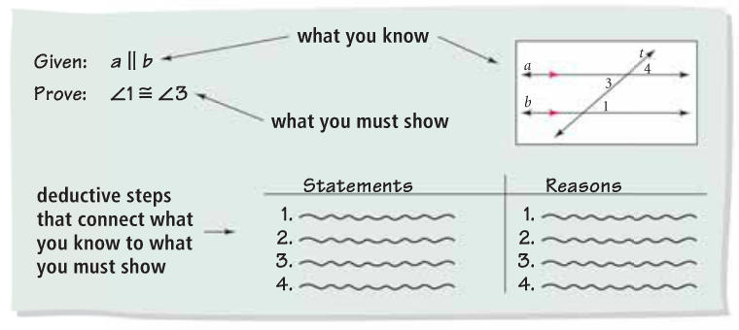

Example 1: Proving Alt. Interior Angles are Congruent

If a transversal intersects two parallel lines, then alternate interior angles are congruent.

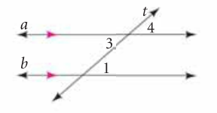

**Given: $a∥b$**

**Prove: $∠1 ≅∠3$**

**Statements Reasons**

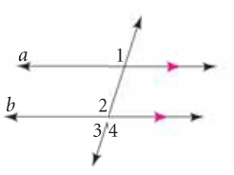Example 2: Proving Alt. Exterior Angles are Congruent

**Given: $a∥b$**

**Prove: $∠1 ≅∠3$**

**Statements Reasons**

Example 3: Finding angle measures

**Given: $a∥b$. Find the measure of the numbered angles**

1

4 2

6 3

$40°$ 5

7 a

b

Example 4: Find the measure of Angle 1 in each pair of parallel lines.

a. b.

1

1 80°

50°

c. d.

1 1

110°

95°

H. Geometry **3-2: Proving Lines Parallel**

**Objective: To use a transversal in proving lines parallel**

**Postulate 3-2: Converse of the Corresponding Angles Postulate**

If two lines and a transversal form corresponding angles that are congruent,

In Lesson 3-1, you proved four theorems based on the ___________________________________________.

You can also prove theorems that are based on its __________________. Let’s take a look.

**Theorem 3-5: Converse of the Alternate Interior Angles Theorem**

If ___________________________________________________________

__________________________________, then the two lines are parallel.

**Theorem 3-6: Converse of the Same-Side Interior Angles Theorem**

If ___________________________________________________________

___________________________________, then the two lines are parallel.

Example 1:

A. Which lines, if any, must be parallel if *m*1 = *m* 2? Justify your answer with a theorem or postulate.

3

E C

D 1 4 K

2

B. Which lines if any, must be parallel if *m*3 = *m*4? Explain.

**Theorem 3-7: Converse of the Alternate Exterior Angles Theorem**

If _________________________________________________________ 1

_______________________________, then the two lines are parallel. a

b

1. 2

**Theorem 3-8: Converse of the Same-Side Exterior Angles Theorem**

If two lines and a transversal form same-side exterior angles that are supplementary, then

Example 2: 

A. Find the value of x for which *l* || *m*. *l*

*m*



B. Find the value of x for which a || b. Explain how you can check your answer.



a

b



Example 3:

A. Two workers are painting lines for angled parking spaces. The first worker paints a line so that

. The second worker paints a line so that. Explain why their lines are parallel.

B. If the second worker uses 3, what should *m* 3 be for parallel lines? Explain.