**H. Geometry – Bellwork #39 Date: _________**

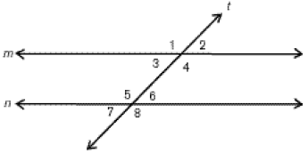For #1 and #2, use the diagram to the right.

**1. Given:  Prove:** 

|  |  |
| --- | --- |
| Statements | Reasons |
| 1) | 1) Given |
| 2) | 2) |
| 3) | 3) |
| 4) | 4) |

**2. Given:  Prove: **

|  |  |
| --- | --- |
| **Statement** | **Reason** |
| 1) | 1) |
| 2) | 2) |
| 3) | 3) Definition of Linear Pair |
| 4) | 4) |

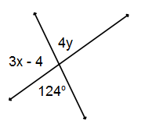

3. Solve for x and y.

x = ______

y = ______