H. Geometry – Bellwork #38 Date: __________

***a, b, c, d,* and *e* are distinct lines in the same plane. For each combination of relationships between the lines, how are *a* and *e* related?**

1.  , , 

2. , , , 

3.  , , 

4. , , , 

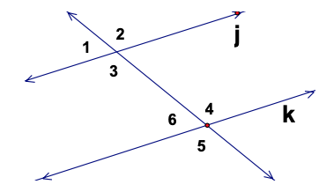

5. Use the diagram at the right:

Given: 

Prove: 

|  |  |
| --- | --- |
| **Statements** | **Justifications** |
|  |  |

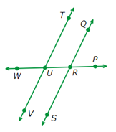

6. Use the diagram at the right:

Given: and are supplementary.

Prove: 

|  |  |
| --- | --- |
| **Statements** | **Justifications** |
|  | Given |
|  | Definition of supplementary angles |
|  |  |
|  | Transitive Property |
|  |  |
|  | Corresponding angles are congruent |