**H. Geometry – Bellwork #29 Date: __________**

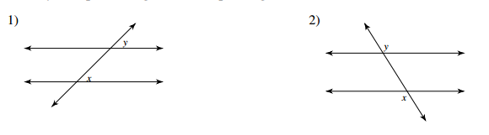

Angle pair name: ______________________ Angle pair name: _______________________

Angle relationship: ________________ Angle relationship: ________________

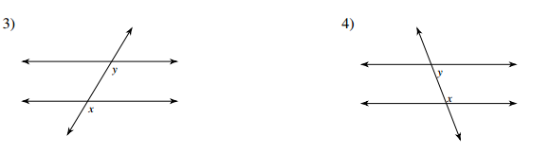

Angle pair name: ______________________ Angle pair name: ______________________

Angle relationship: ________________ Angle relationship: ________________

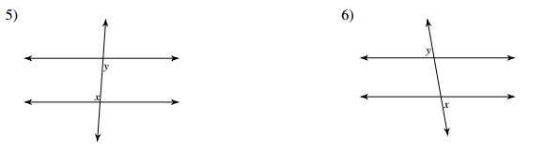

Angle pair name: ______________________ Angle pair name: ______________________

Angle relationship: ________________ Angle relationship: ________________

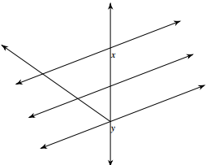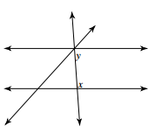

7) 8)

Angle pair name: ______________________ Angle pair name: ______________________

Angle relationship: ________________ Angle relationship: ________________