**H. Geometry – Bellwork #28 Date: __________**

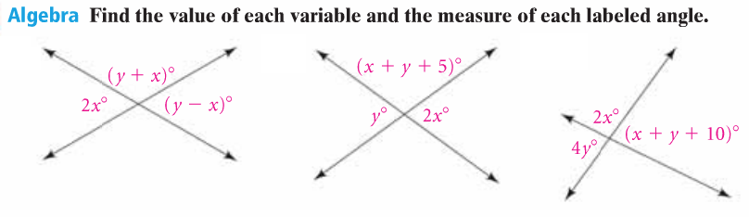

1. 2. 3.

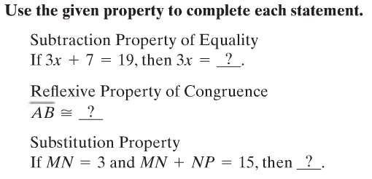

4.

5.

6.

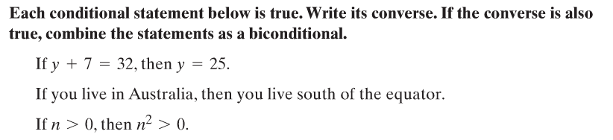

7.

a.

b.

c.