Geometry 3.1-3.3 Review Name: ____________________

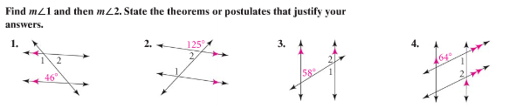

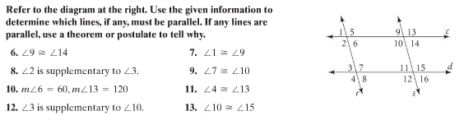

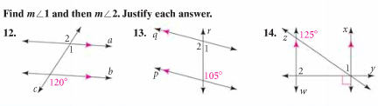

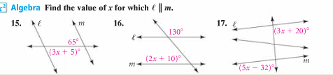

Determine if a and e are parallel or perpendicular using the given information.
18. $a||b,b||c,c||d,d⊥e$ 19. $a⊥b,b⊥c,c||d,d⊥e$

