H. Geometry 3.1-3.3 Class Review Name: _______________________________

Use the diagram below for questions 1 – 24.

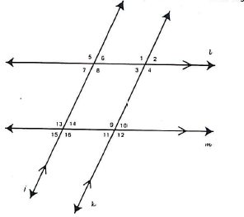

For numbers 1 – 10, classify each angle pair as vertical, corresponding, alternate interior, alternate exterior, same-side interior or same-side exterior angles.

1. $∠$3 and $∠$10 ____________________
2. $∠$15 and $∠$6 ____________________
3. $∠$3 and $∠$9 ____________________
4. $∠$5 and $∠$13 ____________________
5. $∠$2 and $∠$10 ____________________
6. $∠$1 and $∠$12 ____________________
7. $∠$1 and $∠$4 ____________________
8. $∠$14 and $∠$9 ____________________
9. $∠$3 and $∠$6 ____________________
10. $∠$15 and $∠$12 ____________________

For numbers 11-16, state which lines must be parallel if the given angle relationships are true.

11. $∠5≃∠1$ ____________
12. $m∠8+m∠\text{14}=\text{180}°$ ____________
13. $∠2≃∠\text{11}$ ____________
14. $∠\text{16}≃∠9$ ____________
15. $m∠6+m∠1=\text{180}°$ ____________
16. $m∠\text{13}+m∠\text{10}=\text{180}°$ ____________

Find the missing angle measures. Justify your answer.
17. If $m∠8=\text{60}°$, then $m∠3=\text{_______}$
Reason:

18. If $m∠\text{14}=\text{72}°$, then $m∠\text{11}=\text{______}$
Reason:

19. If $m∠9=\text{112}°$, then $m∠1=\text{______}$
Reason:

20. If $m∠2=\text{58}°$, then $m∠5=\text{_____}$
Reason:

21. If $m∠4=\text{120}°$, then $m∠5=\text{______}$
Reason:

22. If $m∠7=\text{54}°$, then $m∠6=\text{______}$
Reason:

23. If $m∠\text{10}=\text{80}°$, then $m∠3=\text{_____}$
Reason:

24. If $m∠8=\text{115}°$, then $m∠\text{14}=\text{______}$
Reason:
Identify all pairs of angles of the given type using the diagram below.
.
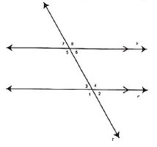
25. Corresponding angles

26. Alternate interior angles

27. Same-side interior angles

28. Alternate exterior angles

29. Same-side exterior angles

Complete the statement using the diagram below.
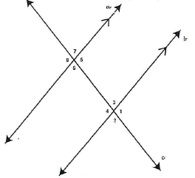
30. $∠$2 and ____ are corresponding angles

31. $∠$5 and ____ are alternate interior angles

32. $∠$4 and ____ are same-side interior angles

33. $∠$8 and ____ are alternate exterior angles

34. $∠$1 and ____ are same-side exterior angles
35. Find $m∠1$ and $m∠2$. Justify your answer.
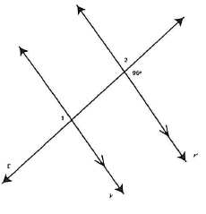

36. Find $m∠1$ and $m∠2$. Justify your answer.

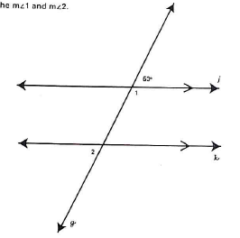

37. Find the value of x that makes p||q if $m∠1=3x$ and $m∠6=\text{120}°$

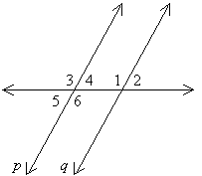

Which lines or segments are parallel? Justify your answer.

38.
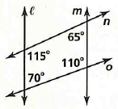

39.
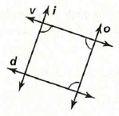

40.
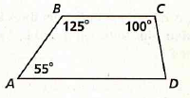

41.
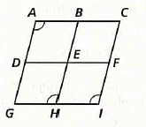

a, b, c, d, and e are distinct lines in the same plane. For each combination of relationships between the lines, how are a and e related?

42. $a||b,$ $b||c$, $c⊥d$, $d||e$

43. $a⊥b$, $b||c$, $c||d$, $d⊥e$

44. $a||b,$ $b||c$, $c⊥d$, $d⊥e$

45. $a⊥b$, $b⊥c$, $c||d$, $d⊥e$

