Geometry 3-4: Parallel Lines and the Triangle Angle-Sum Theorem

Objective 1: To classify triangles and find the measure of their angles.

Theorem 3-12: Triangle Angle-Sum Theorem
The sum of the measures of the angles of a triangle is _________.
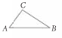

Example 1: Applying the Triangle Angle –Sum Theorem
A) Find the values of x and y.
To find the value of x, use
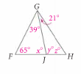
To find the value of y,

B) Find the value of z two different ways using the Triangle Angle-Sum Theorem.

In Chapter 1, you classified an angle by its _________________. You can also classify a triangle by its _______________ and _____________.

By Sides:

_____________________ _____________________ ____________________
_____________________ _____________________ ____________________
By Angles:

______________________ _____________________ __________________
______________________ _____________________ __________________

_____________________
_____________________

Example 2: Classifying a Triangle
A: Classify each triangle by its sides and its angles.
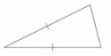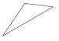

B: Draw and mark a triangle to fit each description. If no triangle can be drawn, write not possible and explain why.

a.) acute scalene b.) isosceles right c.) obtuse equiangular

Objective 2: To use exterior angles of triangles

An ________________________ of a polygon is an angle formed by a side and an extension of an adjacent side. For each exterior angle of a triangle, the two nonadjacent interior angles are its ___________________________________________________________.

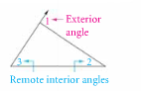
Theorem 3-13: Triangle Exterior Angle Theorem
The measure of each exterior angle of a triangle equals
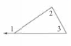

Example 3: Using the Exterior Angle Theorem to find each missing angle measure
A. B.
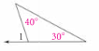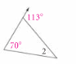

C. D. Explain how you can find the measure of $∠$1 in
Ex C without using the Exterior Angle Theorem.
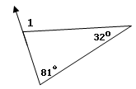

E. Two angles of a triangle measure 45. Find the measure of an exterior angle at each vertex.
(Hint: draw a picture)

Example 4: The lounge chair has different settings that change the angles formed by its parts. Suppose $m∠2=\text{32}°$ and $m∠3=\text{81}°$. Find $m∠1$, the angle formed by the back and the arm rest.
