Geometry 3-3: Parallel and Perpendicular Lines

Objective: To relate parallel and perpendicular lines

There are two ways to draw parallel lines. You can draw them _____________________________ ______________________________________________________________________________.

Symbol for parallel: Symbol for perpendicular:

Theorem 3-9:
If two lines are parallel to the same line,
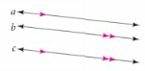
Theorem 3-10:
In a plane, if two lines are perpendicular to the same line,
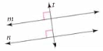

Example 1:
How are a and e related? (Hint: draw a picture)
A.) a || b, b || c, cd, d || e B.) ab, bc, cd, de

a and e are _________________ a and e are __________________

Example 2: To make a frame for a painting, a miter box and backsaw are used to cut the framing at $\text{45}°$ angles. Explain why cutting the framing at this angle ensures that opposite sides of the frame will be parallel.
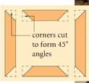

QC 2: Can you assemble the framing below into a frame with opposite sides parallel? Explain.
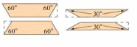

Theorem 3-11:
In a plane, if a line is perpendicular to one of two parallel lines,
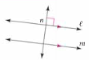

Example 3: Use Theorem 3-11 to show each of the following
A. Given: In a plane, ab, bc, and cd.
Prove: ad

B. From what is given in Example 3A, can you also conclude b||d? Explain.

