Geometry 3-1: Properties of Parallel Lines Date: __________

Objective 1: You will be able to identify angles formed by two lines and a transversal.

A __________________ is a line that intersects two coplanar lines at two distinct (different) points.
The diagrams below show the eight angles formed by a transversal _____ and two lines _____________.

Pairs of the eight angles have special names as suggested by their positions.

$∠$1 and $∠$2 are ____________ $∠$1 and $∠$4 are __________________ $∠$1 and $∠$7 are
________________________. ______________________. ___________________
_____________.
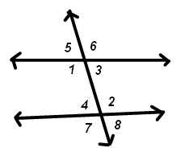

Example 1: Identifying Angles
- Name three other pairs of corresponding angles in the diagrams above.

- Classify the following angles using the diagram below.
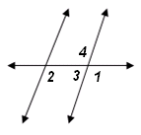

$∠$1 and $∠$2:

$∠$2 and $∠$3:

$∠$2 and $∠$4:

Tips to remember each type of angle.
Corresponding:

Alternate Interior:

Same-side Interior:
Objective 2: You will be able to identify & understand properties of parallel lines.

Postulate 3-1: Corresponding Angles Postulate t
If a transversal intersects two parallel lines, then l
m

In a diagram, to show that two lines are parallel we draw _____________ on the lines. Let’s show that below:

Theorem 3-1: Alternate Interior Angles Theorem t
If a transversal intersects two parallel lines, then a
3 2
b 1

Theorem 3-2: Same-Side Interior Angles Theorem
If a transversal intersects two parallel lines, then

Proof of Theorem 3-1:

Theorem 3-3: Alternate Exterior Angles Theorem
If a transversal intersects two parallel lines, then a 1 2

b
3

Theorem 3-4: Same-Side Exterior Angles Theorem
If a transversal intersects two parallel lines, then

Example 3: Finding Measures of Angles
A. Find m$∠$1 and then m$∠$2. Which theorem or postulate justifies each answer?

B. Find the measure of each angle. Justify each answer.
a. $∠$3 b. $∠$4

c. $∠$5 d. $∠$6

e. $∠$7 f. $∠$8

Using Algebra to find Angle Measures:
Example 4: Find the value of each variable in the diagrams.
A. Find the value of x and y in the diagram

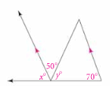

B. Find the values of x and y. Then find the measures of the angles.
(Hint: Find the value of x first.)

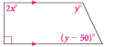

C. Find the measures of angle a, b and c.
