**Objective: I will be able to apply the segment addition postulate.**



A _______________ of a segment is a point that divides the segment into __________________

_________________. A midpoint, or any line, ray, or other segment through a midpoint, is said to _____________ the segment. Let’s draw a segment with its midpoint and label it below.

What equations could you write? 1)

2)

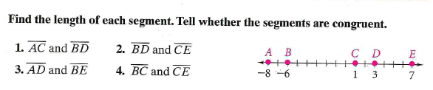

1. AC = _____ 2. BD = _____ 3. AD = _____ 4. BC = _____

BD = _____ CE = _____ BE = _____ CE = _____

Congruent? ______ ______ _______ ______

**Use the figure below to answer questions 5 – 9.**



5. Write an equation using the segment addition postulate. ______________________

6. If RS = 15 and ST = 9, then RT = _______

7. If ST = 15 and RT = 40, then RS = ______

8. If RS = 12, ST = 2x + 1, and RT = 29, find the value of x. Then find the value of ST.

x = _____

RT = _____

9. If RS = 3x + 1, ST = 2x – 2, and RT = 64, find the value of x, RS, and ST.

x = _____

RS = _____

ST = _____



10. Look at 

If the length of is 300, what is the length of ?

11. Points *P*, *Q*, and *R* are collinear, with *Q* between *P* and *R*. What is the length of ?