Geometry Angle Addition Classwork Name: ________________________

Hour: _____

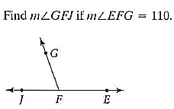1. 2.

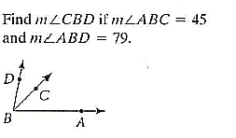

 

3. Find the value of *x* and then find 4. Find the value of x if .

and . Then find  and 

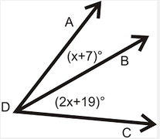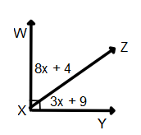

 

5. 6.

