Geometry Worksheet Name _____________
Distance and Midpoints Per __ Date ________

Use the number line to calculate each item:
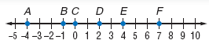
1. AB = _____ 2. AD = ______ 3. CF = ______ 4. BE = _______

5. Midpoint of = _____ 6. Midpoint of = _____

7. Midpoint of = _____ 8. Midpoint of = _____

Use the distance formula to find the distance between each pair of points:
9. (7, 11) and (-1, 5) 10. (2, 0) and (8, 6)

11. (-2, -1) and (3, 11) 12. (-2, -6) and (6, 9)

13. (-10, 2) and (-7, 6) 14. (-3, 2) and (6, 5)

15. 16.
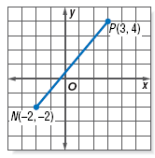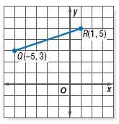

Calculate the midpoint of each segment with the given endpoints:
17. A (9, 5) and B (17, 4) 18. C (8, 4) and D (12, 2)

19. E (-11, -4) and F(-9, -2) 20. A (4, 2) and B (8, -6)

21. A (-4, 3) and B(-1, 5) 22. A (2, 8) and B (-2, 2)

Point M is the midpoint of , find the coordinates of the missing endpoint when you are given one endpoint and the coordinates of the midpoint.
23. M (0, 5.5) and C(-3, 6) 24. M (-1, 5) and A(-4, 3)

25. M (-2, 2) and A(2, 8) 26. M (4, 1) and A(5, -1)

Review:
27. Point A is between points M and C. If MC = 7x, AM = 2x+8, and AC = 3x+6, find the measure of each segment. | 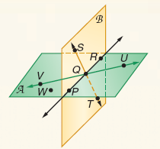  28.  a. Name the intersection of planes A and B:  b. Name 4 coplanar points:  c. Name 3 collinear points:  d. Name 3 non-collinear points:  - Name 4 non-coplanar points:  f. Name the line with pt. V in 3 different ways:

