**Geometry – Bellwork #9 Date: _______**

**Angle Addition Postulate**

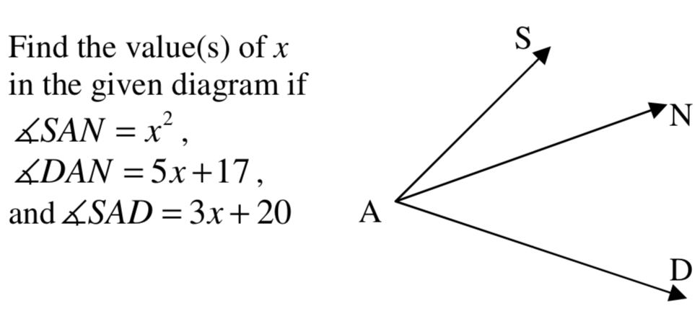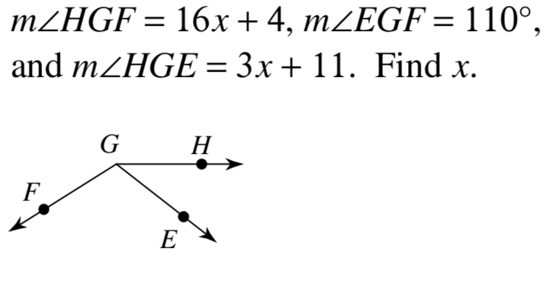

1. 2.

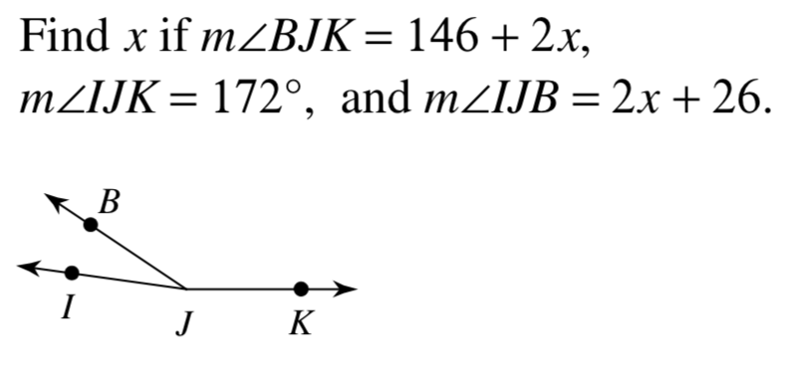

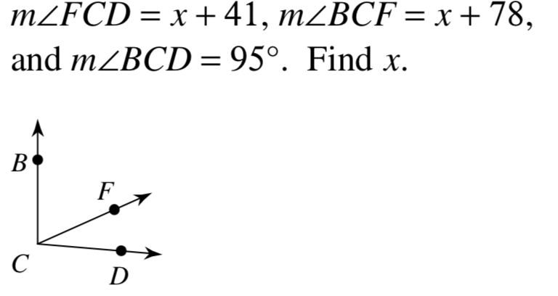3. 4.

**Geometry – Bellwork #9 Date: _______**

**Angle Addition Postulate**



1. 2.



3. 4.