**Geometry – Bellwork #7 Date: ______**

Given: RS = TU, ST = 9, RU = 33

R

S

T

U

B

C

U

T

U

1. Find RS

2. Find SU.

3. Y is between X and Z. Find the distance between points X and Z if the distance between X and Y is 12 units and the distance between Y and Z is 25 units. (Hint—draw a picture.)

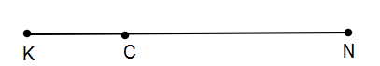**Use the diagram at the right to answer questions 4 – 9.**

4. Name all labeled segments.

5. What equation can you write about the segments?

6. If KC = 12 and KN = 38, then CN = ________

7. If CN = 19 and KC = 11, then KN = ________

8. KC = 2x – 1, CN = 3x + 5, and KN = 24. Find x, KC and CN.

9. KC = x + 3, CN = 4x + 1, and KN = 8x – 4. Find x, KC, CN, and KN.

10. EM = FM and you are told that EM = 5x – 7 and that FM = 9x – 35. What are the lengths of EM, FM, and EF?