**H. Geometry – Bellwork #19 Date: __________**

**Identify the following from the diagram. Make sure you use appropriate symbols and markings.**

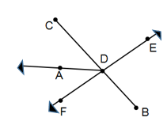

1. A line ________

2. A segment ________

3. A ray ________

4. An angle _________

5. Identify 3 collinear points ____________

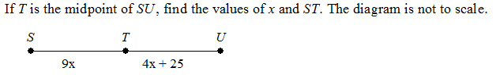6.

**H. Geometry – Bellwork #19 Date: __________**

**Identify the following from the diagram. Make sure you use appropriate symbols and markings.**



1. A line ________

2. A segment ________

3. A ray ________

4. An angle _________

5. Identify 3 collinear points ____________

6.