**H. Geometry – Bellwork #18 Date: __________**

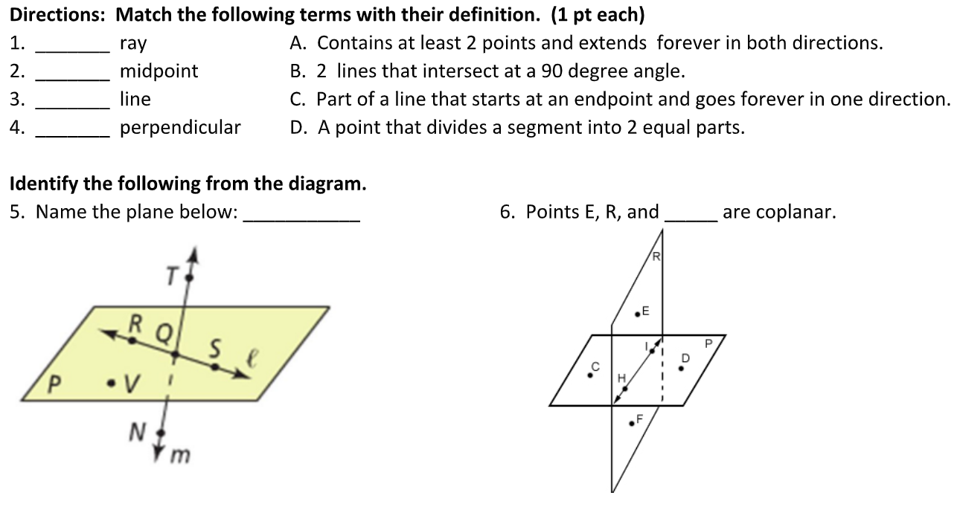

**H. Geometry – Bellwork #18 Date: __________**

