**H. Geometry – Bellwork #16 Date: ______**

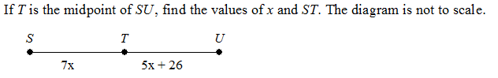1.)



2.)

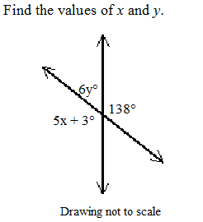3.)

4.) Two lines are parallel iff they don’t intersect.

Write the two conditionals that form this biconditional.

1.

2.