**H. Geometry – Bellwork #15 Date: ______**

Use the diagram below for questions 1 – 6.

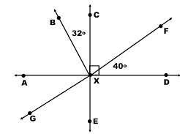1. Name a right angle. _______

2. Name a pair of complementary angles. _____ and _____

3. Name a pair of vertical angles. ______ and ______

4. Name a pair of supplementary angles. ______ and ______

5. Name a straight angle. ______

6. Find the measure of the angles below:



**H. Geometry – Bellwork #15 Date: ______**

Use the diagram below for questions 1 – 6.

1. Name a right angle. _______

2. Name a pair of complementary angles. _____ and _____

3. Name a pair of vertical angles. ______ and ______

4. Name a pair of supplementary angles. ______ and ______

5. Name a straight angle. ______

6. Find the measure of the angles below:

