**H. Geometry – Bellwork #13 Date: __________**

An endpoint and a midpoint are given. Find the coordinates of the other endpoint.

1. endpoint (2,6); midpoint (5, 12) 2. endpoint (2, 3); midpoint (3, -4)

3. The midpoint of RS is N (-4, 1). One endpoint is S (0, -7).

a. What are the coordinates of R?

b. What is the length of RS to the nearest tenth of a unit?

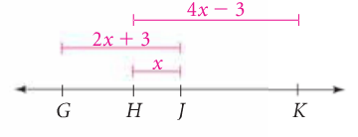

4. Use the diagram at the right.

a. Write an algebraic expression that represents *GK*.

b. If *GK = 30*, find *GH* and *JK*.

**H. Geometry – Bellwork #13 Date: __________**

An endpoint and a midpoint are given. Find the coordinates of the other endpoint.

1. endpoint (2,6); midpoint (5, 12) 2. endpoint (2, 3); midpoint (3, -4)

3. The midpoint of RS is N (-4, 1). One endpoint is S (0, -7).

a. What are the coordinates of R?

b. What is the length of RS to the nearest tenth of a unit?

**

4. Use the diagram at the right.

a. Write an algebraic expression that represents *GK*.

b. If *GK = 30*, find *GH* and *JK*.