1. If M is the midpoint of, find x if LM = 4x – 3 and MN = 5x – 10.

x = ______

2. Find LM if MN = 7 and LN = 16.

LM = _____

3. If LN = 28, LM = 2x – 1 and MN = 3x + 4, find x, LM and MN.

x = ______

LM = ______

MN = ______

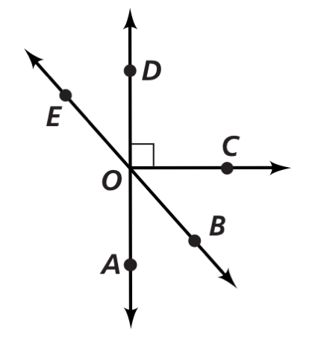**Use the diagram at the right to answer questions 4 – 9.**

4. Name a pair of vertical angles.

5. Name a right angle.

6. Name an angle that is supplementary to 

7. Name an angle that is complementary to 

8. Name a straight angle.