**Geometry – Bellwork #11 Date: __________**

1. *A (4, -1)* and *B (-2, 3)* are points in a coordinate plane. *M* is the midpoint of segment *AB*. What is the length of segment *MB* to the nearest tenth of a unit?

2. For a – b, one endpoint and the midpoint are given in a segment. Find the other endpoint.

a. midpoint (-4, 3); endpoint (2, 7) b. midpoint (-3, -1); endpoint (5, 2)

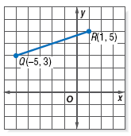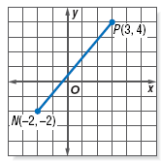3. What is the distance between point *P & N*? 4. What is the distance between point *R & Q*?

**Geometry – Bellwork #11 Date: __________**

1. *A (4, -1)* and *B (-2, 3)* are points in a coordinate plane. *M* is the midpoint of segment *AB*. What is the length of segment *MB* to the nearest tenth of a unit?

2. For a – b, one endpoint and the midpoint are given in a segment. Find the other endpoint.

a. midpoint (-4, 3); endpoint (2, 7) b. midpoint (-3, -1); endpoint (5, 2)

3. What is the distance between point *P & N*? 4. What is the distance between point *R & Q*?