Henry Ford Early College
H. Geometry: Unit 1 Review
Unit 1: Vocabulary Essentials and Angle Relationships
Chapter 1: Sections 1.3-1.6, 1.8

Directions: Match the following terms with their precise definitions.
1.____line segment A. Lines that are coplanar and do not intersect.
2.____perpendicular lines B. Part of a line consisting of 2 endpoints.
3.____parallel lines C. Formed by 2 rays with the same endpoint.
4.____angle D. 2 Lines that intersect at a 90 angle.

Directions: Identify the following from the diagram.
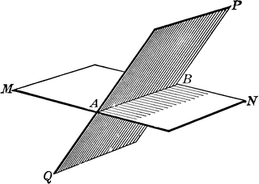
5) 3 Collinear points __________

6) 3 coplanar points __________

7) a plane__________
Directions: Identify the following from the diagram. Make sure you have the appropriate geometric markings.
T
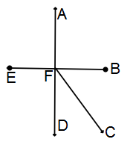
8) Line____________

9) Segment_____________

10) Ray___________

11) Angle_______________

12) Opposite rays _____________

13.)

Directions: Draw and label the following correctly.
Perpendicular Bisector  14) | Angle Bisector  15) | Obtuse Angle  16)
Acute Angle  17) | Point  18) | Opposite Rays  19)

20.)

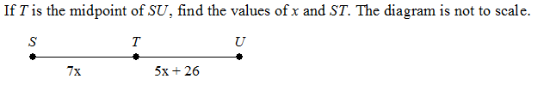
21.)

22.)

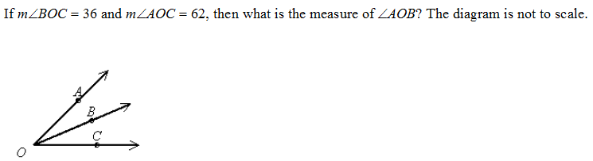
23.)

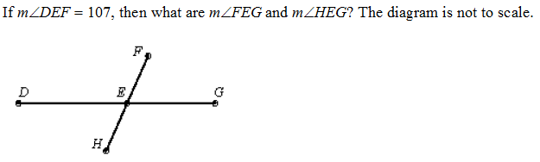
24.)

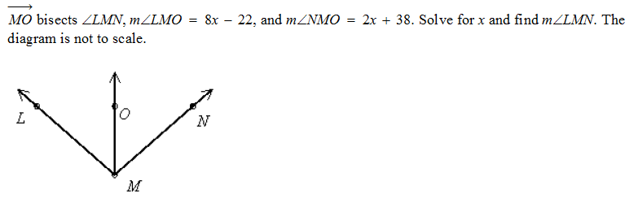
25.)

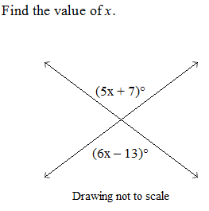
26.)

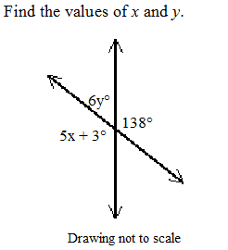
27.)

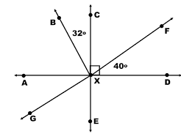
Use the diagram below for questions 28 – 33.

28. Name a right angle. _______

29. Name a pair of complementary angles. _____ and _____

30. Name a pair of vertical angles. ______ and ______

31. Name a pair of supplementary angles. ______ and ______

32. Name a straight angle. ______

33. Find the measure of the angles below:
$\begin{aligned}m∠\text{AXB}=\text{_____} \\ m∠\text{CXF}=\text{_____} \\ m∠\text{AXG}=\text{_____} \\ m∠\text{EXD}=\text{_____} \\ m∠\text{BXG}=\text{_____} \\ m∠\text{BXF}=\text{_____}\end{aligned}$

