**H. Geometry Section 2.2 – Biconditional and Definitions Date: _______**

**Objective 1:** I can write a biconditional statement by identifying if a conditional and its converse are true.

When a conditional and its converse are true, you can combine them as a true ____________________. This is the statement you get by connecting the conditional and its converse with the word _________. You can write a biconditional more concisely, however, by joining the two parts of each conditional with the phrase ____________________.

Example 1: Writing a Biconditional

A. Consider this true conditional statement. Write its converse. If the converse is also true, combine the statement as a biconditional.

Conditional: If two angles have the same measure, then the angles are congruent.

Converse:

Biconditional:

B. Consider this true conditional statement. Write its converse. If the converse is also true, combine the statements as a biconditional.

Conditional: If three points are collinear, then they lie on the same line.

Converse:

Biconditional:

C. Consider this true conditional statement. Write its converse. If the converse is also true, combine the statements as a biconditional.

Conditional: If a figure is a triangle, then it has exactly three sides.

Converse:

Biconditional:

D. Consider this true conditional statement. Write its converse. If the converse is also true, combine the statements as a biconditional.

Conditional: If a number is greater than zero, then it is positive.

Converse:

Biconditional:

You can write a biconditional as two conditionals that are __________ of each other.

Example 2: Finish this biconditional

A number is even IF AND ONLY IF _______________________________.

Write the two conditionals that make up this biconditional.

Example 3: Separating a Biconditional Into Parts

A. Algebra: Write two statements that form this biconditional about whole numbers.

A number is divisible by 3 if and only if the sum of its digits is divisible by 3.

B. Write two statements that form this biconditional about integers greater than 1.

A number is prime if and only if it has two distinct factors, 1 and itself.

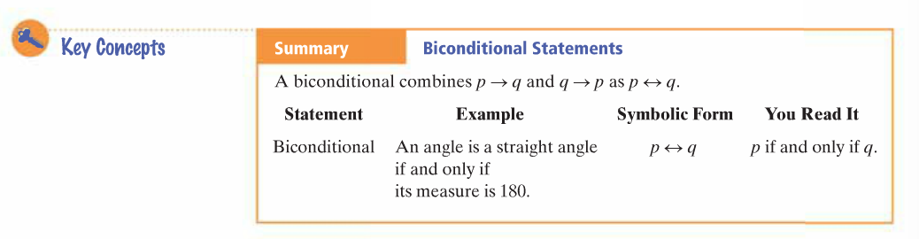

Good Definitions:

* ________________________
* ________________________
* ________________________

**Objective 2**: I can identify good definitions by using biconditionals.

Example 4:

A. Is this a good definition of Parallel Lines?

Two lines are parallel iff they don’t intersect.

Write the two conditionals that form this biconditional.

1.

2.

B. Is this a good definition of a square?

A figure is a square iff it has four right angles.

Write the two conditionals that form this biconditional.

1.

2.

Example 5:

A. Congruent figures have the same shape.

Write this statement has a biconditional.

B. Is this a good definition of Congruent Figures?

Is the biconditional true?