**H. Geometry – Introduction to Section 2.4 Date: __________**

Solve each equation.

1. 2.

3. 4.

5.

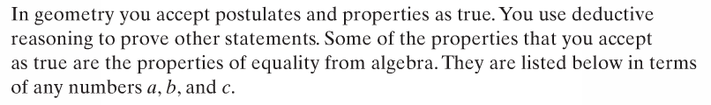

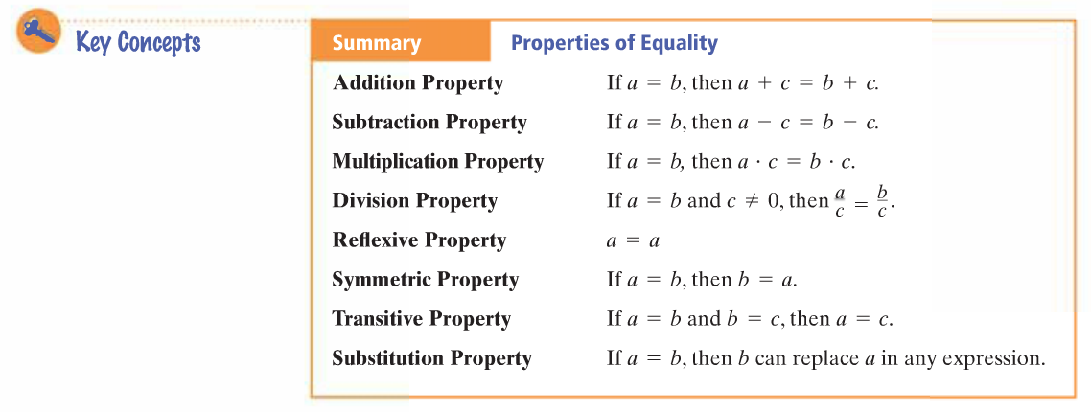



Solve this equation. Justify the steps. 5x + 3 = -12

____Steps____ ____Reasons____

Solve this equation. Justify the steps. 6 + 2(3x + 1) = 38

____Steps____ ____Reasons____