**Geometry Section 1.6 - Angles Date: __________**

**Objective 1: Classifying/Naming Angles**

An ______________ is formed by two rays with the same endpoint. The rays are the ______________ of the angle. The endpoint is the vertex of the angle.

**Use the angle below right to answer the questions.**



1) Name the sides of the angle. 2) Name the vertex of the angle.

3) Name the angle in as many ways as possible.

**Example 1:** Name  in the photo below in two other ways.

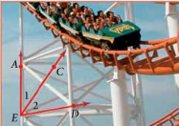

**QC 1:**

A) Name  two other ways. B) Would it be correct to name any of the angles? Explain.

1.) Acute Angles ______________ 3.) Obtuse Angles ______________

2.) Right Angles ______________ 4.) Straight Angles ______________

**Example 2:** Classify each angle as *acute, right, obtuse*, or *straight*.

A) B) C) D)

   

**Objective 2: I can apply the angle addition postulate.**

In geometry, we have a rule, or a ________________, that is similar to the Segment Addition Postulate the Angle Addition Postulate.

|  |
| --- |
| **Postulate: Angle Addition Postulate**  If point B is in the interior of , then If  is a straight angle, then |

**Example 3:** Use the angle addition postulate to find each missing angle.

A) What is if  B) If , find 

and ?

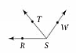 

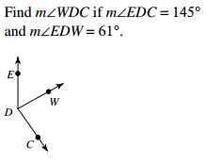

C) D)

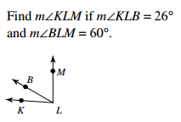

**Example 4:** Sometimes the angle measures have variable expressions rather than numbers.

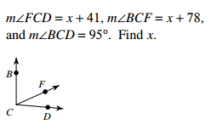A)

**Example 4 (continued):**

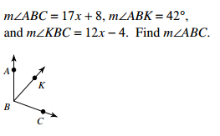B) Solve for *x* if  C)

and .



**Objective 3: Using angle bisectors**

Recall from earlier that bisect means to ___________________________________________. An angle can be _____________ by a line, ray or segment. Let’s draw an example below.

**Example 5:** Find  in the figure below.

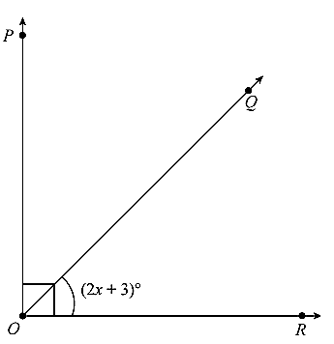

**Example 6:** Find the value of x.

