Geometry 1.5 & 1.6 Quiz Review Date: ______

- What is the definition of the Segment Addition Postulate? Draw a diagram and give an equation that represents it.

- What is the definition of the Angle Addition Postulate? Draw a diagram and give an equation that represents it.

Vocabulary: Midpoint, angle, acute angle, right angle, obtuse angle, straight angle, vertical angle, adjacent angle, complementary angle, supplementary angle.

Use the line segment below for questions 1 – 3.

1. If M is the midpoint of $\overline{\text{LN}}$, find x if LM = 4x – 3 and MN = 5x – 10.

x = ______

2. Find LM if MN = 7 and LN = 16.

LM = _____

3. If LN = 28, LM = 2x – 1 and MN = 3x + 4, find x, LM and MN.

x = ______
LM = ______
MN = ______

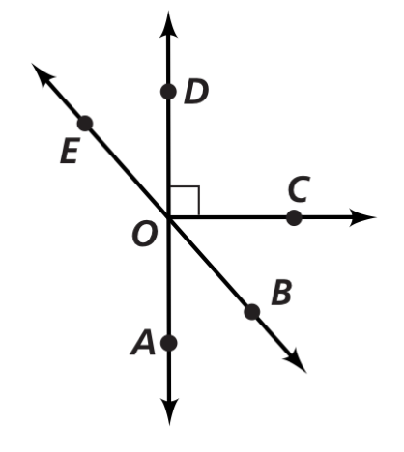
Use the diagram at the right to answer questions 4 – 9.

4. Name a pair of vertical angles.

5. Name a right angle.

6. Name an angle that is supplementary to $∠\text{DOE}\text{.}$

7. Name an angle that is complementary to $∠\text{AOB}\text{.}$

8. Name a straight angle.
9. If $m∠\text{EOD}=\text{40}°,$find the measure of the angles below.

$\begin{aligned}m∠\text{EOA}=\text{______} \\ m∠\text{AOB}=\text{______} \\ m∠\text{BOC}=\text{______} \\ m∠\text{DOC}=\text{______}\end{aligned}$

Decide whether each angle below is acute, right, obtuse, or a straight angle.

10. 11.
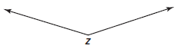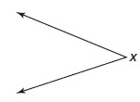

_________________________ ________________________

12. Name the angle below in 2 different ways.

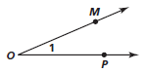

Use the diagram below for 13 and 14.
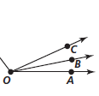

13. If $m∠\text{COA}=\text{58}°$ and $m∠\text{BOA}=\text{24}°$, find $m∠\text{AOB}\text{.}$
$$m∠\text{AOB}=\text{______}$$

14. If $m∠\text{AOB}=x+3,$ $m∠\text{AOC}=2x+\text{11},$ and $m∠\text{BOC}=4x−7$, find the value of x.

x = __________

15. $∠1$ and $∠2$ form a straight angle. If $m∠1=2x−3$ and $m∠2=3x−7$, find x.

