**Geometry Distance and Midpoint Formula Notes Date: _________**

**Objective 1: Finding the length of a segment in the x-y plane.**

So far we have seen how to use the segment addition postulate to find the length of several segments. But what if the segment is graphed in the x-y coordinate plane, like below?

* 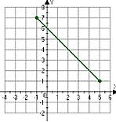You can’t just count the squares to see how long it is…that only works with _______________ and _____________ lines. When a segment is graphed in the x-y plane, we use the _____________________ to find its length.

**DISTANCE FORMULA IN THE X-Y PLANE**

To find the distance between two points __________ and ___________, use the formula below:

Ex 1: Find the distance of the segment in the diagram above.

*First, write the ____________ of the segment’s ______________.

* Label the points  and if that helps.

*Now plug the numbers into the distance formula.

Ex 2: Find the distance between the two points.

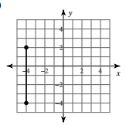

Ex 3: Find the distance between the two points.

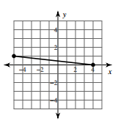

Did we need to use the distance formula for this example? Why or why not?

Ex 4: Find the distance between the points (-1, 4) and (5, -3).

Ex 5: Find the distance between the points (-2, -8) and (7, 9).

Ex 6: Find the distance between the points (0, 1) and (-4, -2).

**Objective 2: Finding the midpoint of segment in the x-y plane.**

Recall from earlier in this unit, that the midpoint of a segment ______________________________

________________. Now we will see how to find the midpoint of a segment in the x-y plane. We will also learn to find an endpoint if given an endpoint and a midpoint of segment.

|  |
| --- |
| **MIDPOINT FORMULA IN THE X-Y PLANE**  To find the midpoint of a segment whose endpoints are _______ and ______, use the formula: |

Ex 7: Find the midpoint of the segment Ex 8: Find the midpoint of the segment

whose endpoints are (6, 2) and (10, 0). whose endpoints are (-3, 4) and (5, 8).

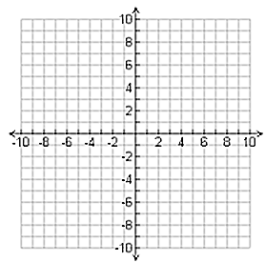

Ex 9: Find the endpoint of a segment whose Ex 10: Find the endpoint of a segment whose

midpoint is (1, 2) and has an endpoint at (-1, 1). midpoint is (0, -4) and has an endpoint at (3, 9).