Geometry Section 1-4 Continued: Segments, Rays, Parallel Lines and Planes

Objective 3: Identifying Segments and Rays

Many geometric figures, such as squares and angles, are formed by parts of lines called
____________________ or ______________.

A __________ is the part of a line consisting of ______________________________________

A __________ is the part of a line consisting of ______________________________________

________________________ are two collinear rays with ______________________________. Opposite rays always form a _________.

Example 1: Name the segments and rays in the figure below.

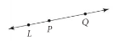

*The segments are:

*The rays are:

QC1: $\vec{\text{LP}}$ and $\vec{\text{PL}}$ form a line. Are they opposite rays? Explain.

Objective 4: Recognizing Parallel Figures

Lines that do not intersect may or may not be coplanar. ________________________ are

__________________________ that do not intersect. ____________________ are ________________; they

are _________________ and _____________________________.

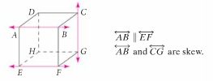

*Segments or rays are parallel if they _______________________________. They are skew if they ________________________________.

Example 2: Use the diagram of the skyscraper to answer Example 1 and QC 1.

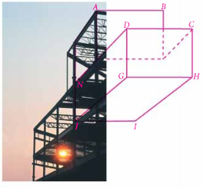
A) Name all labeled segments that are parallel to $\overline{\text{DC}\text{.}}$

B) Name all labeled segments that are skew to $\overline{\text{DC}\text{.}}$

QC 2: A) Name all labeled segments that are parallel to $\overline{\text{GJ}\text{.}}$

B) Name all labeled segments that are skew to $\overline{\text{GJ}\text{.}}$

C) Name another pair of parallel segments. D) Name another pair of skew segments.

______________________ are planes that ________________________________. A line and a plane that do not intersect are also __________________.

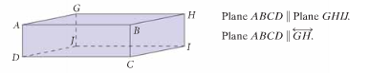

Example 3: Use the diagram above to name the figures.

A) Two pairs of parallel planes B) A line that is parallel to plane GHIJ.

QC 3: Use the figure below to name the figures.
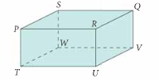
A) Three pairs of parallel planes B) A line that is parallel to plane QRUV.

