Geometry 1.3 and 1.4 Review Name: _____________________________

Use the figure below to answer questions
1-10.
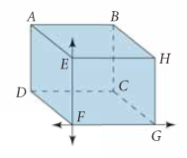
1. Name a line in the figure.
2. Name a segment in the figure.
3. What is the intersection of $\overline{\text{DC}}$ and $\vec{\text{CG}}$?
4. Name two planes that intersect in$\vec{\text{EF}}$.
5. Name the plane represented by the top of the box.
6. Name the plane represented by the bottom of the box.
7. Name the intersection of planes EFG and DEA.
8. Name another point in plane CGH.
9. Name another point in plane FEB.
10. Shade the plane that contains HAD,

Use the figure below to answer questions 11-17.
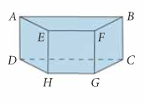
11. Are points A, E, F, and B coplanar?
12. Are points D, C, E, and F coplanar?
13. Are points H, G, F, and B coplanar?
14. Are points A, E, B, and C coplanar?
15. Name all segments parallel to $\overline{\text{GH}}$.
16. Name all segments skew to $\overline{\text{GH}}$.
17. Name a pair of parallel planes.
Use the figure below to answer true or false for questions 18-27.
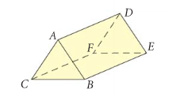

18. A, D, and F are coplanar.
19. A, B, and E are coplanar.
20. $\vec{\text{AC}}$ and $\vec{\text{FE}}$ are coplanar.
21. D, A, B, and E are coplanar.
22. $\vec{\text{FC}}||\vec{\text{EF}}$
23. plane ABC || plane FDE
24. $\vec{\text{BC}}$ and $\vec{\text{DF}}$ are skew lines.
25. $\vec{\text{AD}}$ and $\vec{\text{EB}}$ are skew lines.
26. $\vec{\text{DE}}||\vec{\text{CF}}$
27. D, E, and B are collinear.

Use the figure below to answer questions 28-32.
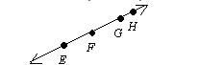

28. Name three different segments.
29. Name three different rays.
30. Name a pair of opposite rays.
31. Name the line in 2 different ways.
32..Do the four points above form a plane? Why or why not?

