**Algebra II - Bellwork #16 February 28th, 2019**

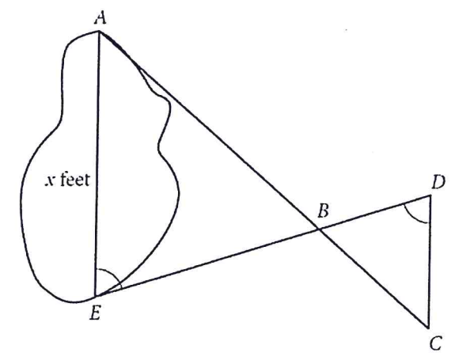

1.)

A summer camp counselor wants to find a length, $x$, in feet, across a lake as represented in the sketch above. The lengths represented by AB, EB, BD, and CD on the sketch were determined to be 1800 feet, 1400 feet, 700 feet and 800 feet, respectively. Segments AC and DE intersect at B, and $∠$ AEB and $∠$ CDB have the same measure. What is the value of x?

2.) If $\left(ax+2\right)\left(bx+7\right)=15x^{2}+cx+14$ for all values of $x$, and $a+b=8$, what are the two possible values for $c$?

A) 3 and 5

B) 6 and 35

C) 10 and 21

D) 31 and 41

3.) Simplify.

$$\frac{3x^{2}+4x+1}{3x^{2}-5x-2}÷\frac{x^{2}-2x-3}{-5x^{2}+25x-30}$$

4.) Find all VA, HA, x-int, and y-int.

$$y=\frac{4x^{2}-3}{x^{2}-x-12}$$