Chapter 21-Absolute Monarchs in Europe-Guided Notes
Section 1-Spain’s Empire and European Absolutism

A Powerful Spanish Empire (pg. 589-591)

Philip II (1527 A.D. to 1598 A.D.)
- Son of Charles V  - Inherited __________, the Spanish ______________ and Spain’s ______________colonies  - Philip was ______, serious, __________________, and aggressive for the _______ ______________________ | 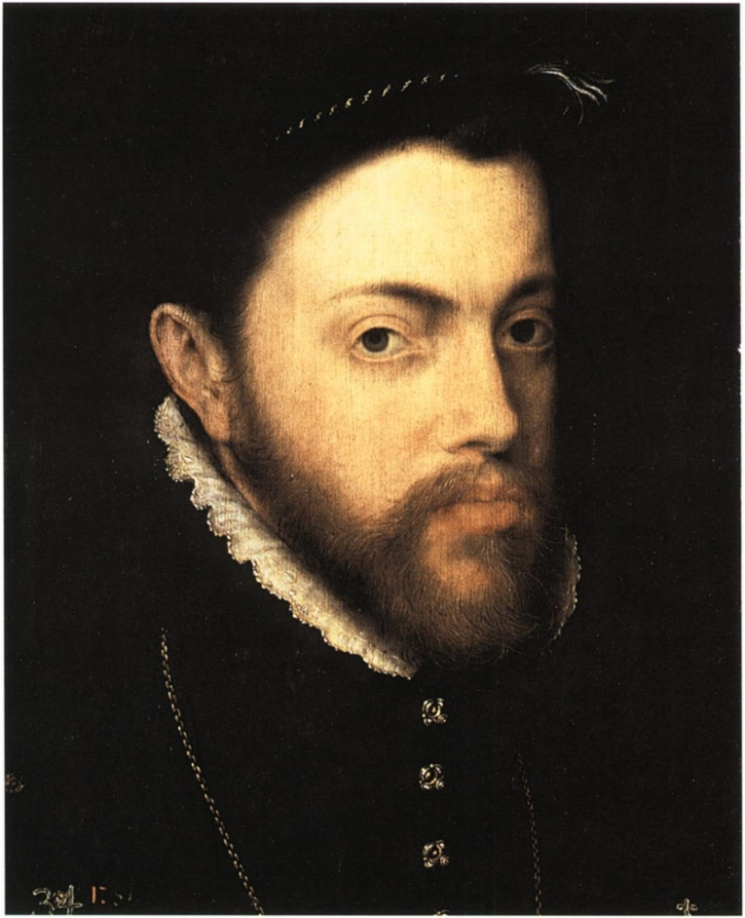 | - Philip II’s Empire-  - Controlled Portugal’s holdings, strongholds in ___________, India, and the _________________  - Received 1/4th to 1/5th of each ships treasure  - Supported an army of 50,000 men  - Defended and supported _______________ against Muslims

Golden Age of Spanish Literature (pg. 591-592)

During the 16th and 17th century Spain experienced a golden age in arts
- El Greco-  - His name means “_________________”  - Paintings represented the ____________________ of Spain  - Were often hard to understand | 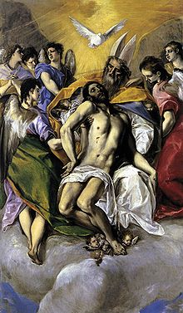 | - Diego Velazquez-  - His paintings reflected the pride of ________ __________________

- Don Quixote-Published in __________
  - Called the “____________________________________”
  - Written by _________________________________
  - Story surrounds a poor man who read to many novels about kings, than went crazy

The Spanish Empire Weakens (pg. 592-593)

Inflation and Taxes | Making Spain’s Enemies Rich
- Inflation-The decline in the ___________ ____________  - Causes of Spanish inflation  - Population had ___________ and due to the increased need for goods merchants raised ____________  - The value of the silver bullion had __________________ | - Spain bought most of their products from ________, ___________________ and the Netherlands  - To finance their wars they borrowed money from _______ _________________________

The Independent Dutch Prosper (pg. 593-594)

The Netherlands | Dutch Art
- The Netherlands won their independence from ___________ in 1579  - They had the best banks and the best artists in Europe during the 1600’s | Rembrandt van Rijn-  - Painted wealthy _______________ and groups  - Famous works also included _________________________ and a series of paintings about Jesus

- Dutch Trading Empire-
  - Had the ______________________ fleet of ships in the world
    - _______________ ships
  - ______________________ Company-
    - Dominated the ___________ and the ______________ trade

Absolutism in Europe (pg. 594-595)

The Theory of Absolutism
Absolute Monarchs-  - ________________________ ________________________ ________________________ | Divine Right-  - _________________________ _________________________ _________________________

Chapter 21-Absolute Monarchs in Europe-Guided Notes
Section 1-Spain’s Empire and European Absolutism

A Powerful Spanish Empire (pg. 589-591)

Philip II (1527 A.D. to 1598 A.D.)
- Son of Charles V  - Inherited Spain, the Spanish Netherlands and Spain’s American colonies  - Philip was shy, serious, deeply religious, and aggressive for the sake of his empire |  | - Philip II’s Empire-  - Controlled Portugal’s holdings, strongholds in Africa, India, and the East Indies  - Received 1/4th to 1/5th of each ships treasure  - Supported an army of 50,000 men  - Defended and supported Catholicism against Muslims

Golden Age of Spanish Literature (pg. 591-592)

During the 16th and 17th century Spain experienced a golden age in arts
- El Greco-  - His name means “the Greek”  - Paintings represented the deep Catholic faith of Spain  - Were often hard to understand |  | - Diego Velazquez-  - His paintings reflected the pride of the Spanish monarchy

- Don Quixote-Published in 1605
  - Called the birth of the modern European novel
  - Written by Miguel de Cervantes
  - Story surrounds a poor man who read to many novels about kings, than went crazy

The Spanish Empire Weakens (pg. 592-593)

Inflation and Taxes | Making Spain’s Enemies Rich
- Inflation-The decline in the value of money  - Causes of Spanish inflation  - Population had increased and due to the increased need for goods merchants raised prices  - The value of the silver bullion had decreased | - Spain bought most of their products from France, England and the Netherlands  - To finance their wars they borrowed money from German and Italian bankers

The Independent Dutch Prosper (pg. 593-594)

The Netherlands | Dutch Art
- The Netherlands won their independence from Spain in 1579  - They had the best banks and the best artists in Europe during the 1600’s | Rembrandt van Rijn-  - Painted wealthy middle-class merchants and groups  - Famous works also included The Night Watch and a series of paintings about Jesus

- Dutch Trading Empire-
  - Had the largest fleet of ships in the world
    - 4,800 ships
  - Dutch East Indian Company-
    - Dominated the spice trade and the Indian Ocean trade

Absolutism in Europe (pg. 594-595)

The Theory of Absolutism
Absolute Monarchs-  - Kings or Queens held all the power within their states boundaries | Divine Right-  - The belief that God created the monarch and monarchy to act as representatives of God

