Name: _________________________________________________

**The Ottoman Empire**

The largest and most important of all the Muslim empires in the post-Medieval period was the Ottoman Empire. At its height, the Ottomans controlled a huge amount of territory around the Mediterranean – even encroaching into European lands.

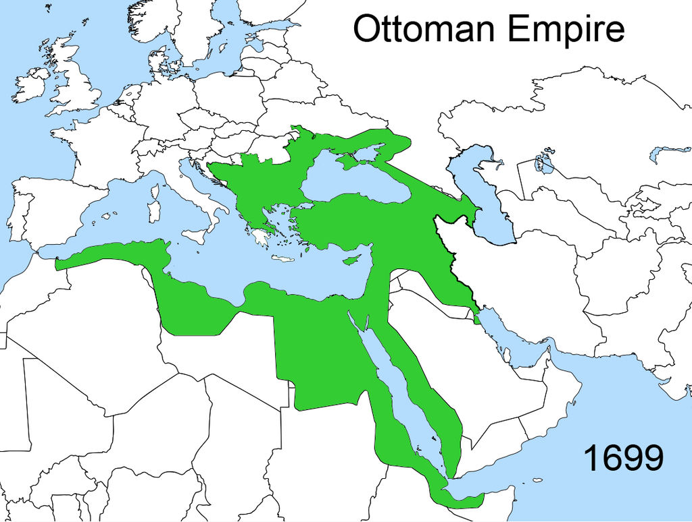

**Origins**

The Ottomans began in Turkey, in the middle of several other Muslim states all competing with one another. The Ottoman military was able to subdue their neighbors and take over the Anatolia peninsula. As the Ottomans continued to expand, eventually the Ottoman ruler Sultan Mehmed achieved their greatest military accomplishment by conquering Constantinople, capital of the Byzantine Empire, in 1453. They defeated the Byzantines using the relatively new technology of cannons, becoming one of the first **gunpowder empires** of the time period to rely on gun technology to defeat their enemies. The Ottomans renamed Constantinople “Istanbul” and were then able to dominate the trade between Europe and Asia as Istanbul stood between the Mediterranean and the Black Sea. This trade would make the Ottomans one of the most powerful states in the world.

**The Sultan**

The Ottoman Empire was an absolute monarchy ruled by the **Sultan.** The main principle underlying their beliefs about government was that the Sultan was supposed to work on the people’s behalf to protect them against corrupt government that might charge them unfair taxes or jail them unjustly. There were several policies that the Sultan used to ensure the government treated the people fairly.

First off, Ottoman laws were written down and publicly posted. Having public laws is crucial to preventing abuse. Because the laws are public, a corrupt tax collector could not say, “Hey, you owe a $1000 tax for your horse,” unless that was actually the case. Or a corrupt policeman could not make up an imaginary fine for crossing the street incorrectly.

Also to ensure that government officials did not abuse their power, the sultan had a vast network of spies whose job it was to observe government officials and report back to the sultan on their activities. Sometimes, the sultan would even tour the empire in disguise to observe officials directly and make sure they were acting correctly!

If a corrupt government official was discovered, they would be subject to harsh punishments. The death penalty was given to any official who taxed the people illegally or who coerced citizens into forced labor. By having such harsh punishments, the Ottoman government made it clear that officials were expected to obey the laws and not abuse their power over the people.

**Ottoman Policies**

Although an absolute ruler, the Sultan still needed a capable bureaucracy to help him run the government. The Ottomans developed a system called “**devshirme**” – where they would take Christian boys between the ages of 7 -10 away from their families. These boys were then converted to Islam and trained to be government officials who could help administer the laws and manage the Ottoman treasury and economy. Years and years of training led to the Ottomans having a large class of highly skilled and loyal bureaucrats. Because these officials had no family ties to the Turkish nobility, the sultan had a capable bureaucracy loyal only to him.

Not every boy taken though became a government official. Many boys were also taken away to join the “**janissaries**” – elite soldiers for the Ottoman army. The same principle of the bureaucrats applied here to these soldiers – by taking such young boys and training them for years and years, the Ottomans had a large, expert fighting force. The strength of this fighting force coupled with the sultan having a capable government allowed the Ottomans to maintain their prosperity for centuries. Although if you ever create your own empire, then kidnapping is strongly discouraged.

The Ottomans also promoted stability through their system of the “**millet**.” Under the millet, Christian and Jewish groups were allowed to live under their own laws instead of Muslim “sharia” law. They were basically independent as long as they paid their taxes. By offering these minorities religious freedom, peace and stability was promoted as they would be less likely to rebel.

**The Ottoman Economy**

Ottoman prosperity depended on their control of global trade. Chinese porcelain, silk, and spices were in HUGE demand in Europe. And smack down in the middle of the Silk Road trade routes between Europe and Asia was the Ottoman Empire. The Ottomans would acquire Chinese goods and then charge European buyers a large mark-up to buy the goods. They were basically middle-men. Europe had to go to the Ottomans to get what they needed, so had to pay heavily for that opportunity.

**Sultan Suleyman (1494-1566):**

The most powerful and famous Ottoman ruler was Sultan Suleyman. Suleyman sought to bring Europe under Ottoman control. He was a successful conqueror and brought parts of Greece, Hungary, and Germany into the Ottoman Empire. Many European rulers were legitimately concerned that the Ottomans would take over the rest of Europe, although Suleyman was never able to make further inroads into Europe.

Suleyman was also known as a great builder. Suleyman sought to make Istanbul the center of Islamic civilization. He built mosques and palaces that rivaled any other building projects at the time. Suleyman patronized one of the greatest architects in history, Sinan. The mosques built by Sinan are considered the greatest architectural triumphs of the Islamic world due to their beauty, majesty, and engineering accomplishments.

**Questions:**

1. How did the Ottoman Empire come to control a large part of the Silk Road trade routes?

2. What was the main purpose of the Sultan according to Ottoman political belief?

3. How did Public declaration of laws and taxes help ensure justice?

4. How did the Sultan deal with corrupt officials?

5. How did the devshirme help lead to an effective government?

6. What were the janissaries and how were they created?

7. How did the Ottoman millet policy work?

8. Why did Europe have to give the Ottomans so much wealth?

9. For what 2 reasons was Suleyman known as such a powerful and influential sultan?