**Write an equation for the line that is perpendicular to the given line and that passes through the given point.**

1. 2. 3.

4. 5. 6.

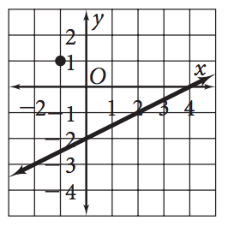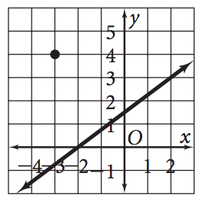

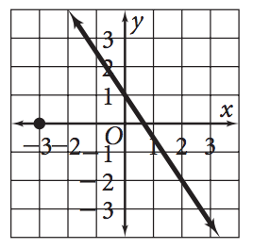7. 8. 9.

**Write an equation for the line that is parallel to the given line and that passes through the given point.**

1. 2. 3.

4. 5. 6.

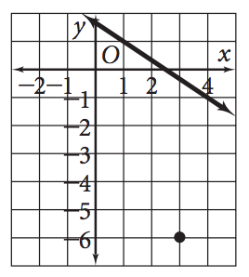

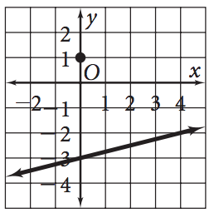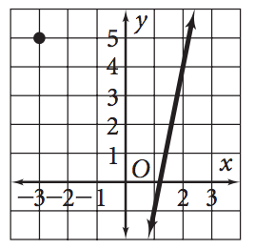7. 8. 9.