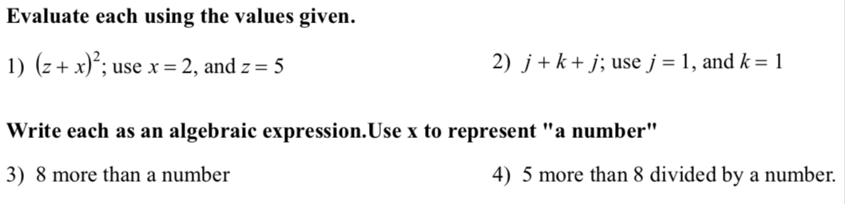

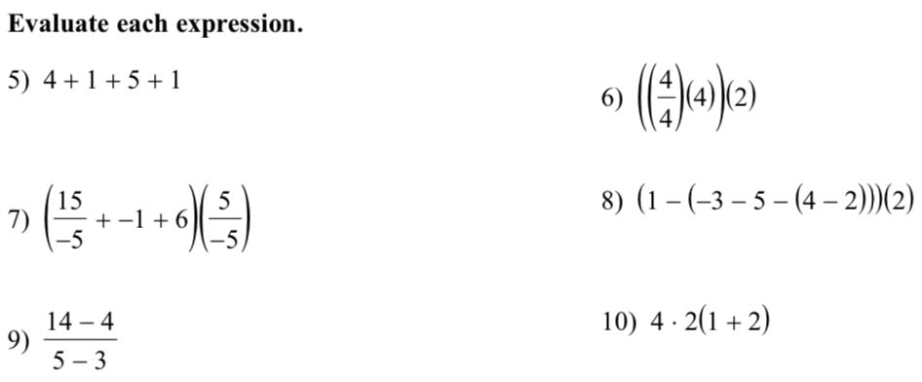

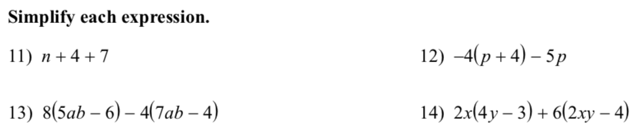

**Solve each equation. If there is no solution, write no solution.**

15. 16.

17. 18.