**Objective: I can solve systems of equations by graphing or by the substitution method.**

**Example 1**: How many solutions does each system of linear equations have?

1. _______________________ 2. _______________________

3. _______________________ 4. _______________________

**Example 2**: Using this line: _______________________

Write the equation of a second line that would lead to the given number of solutions.

1. One solution 2. No solution 3. Many solutions

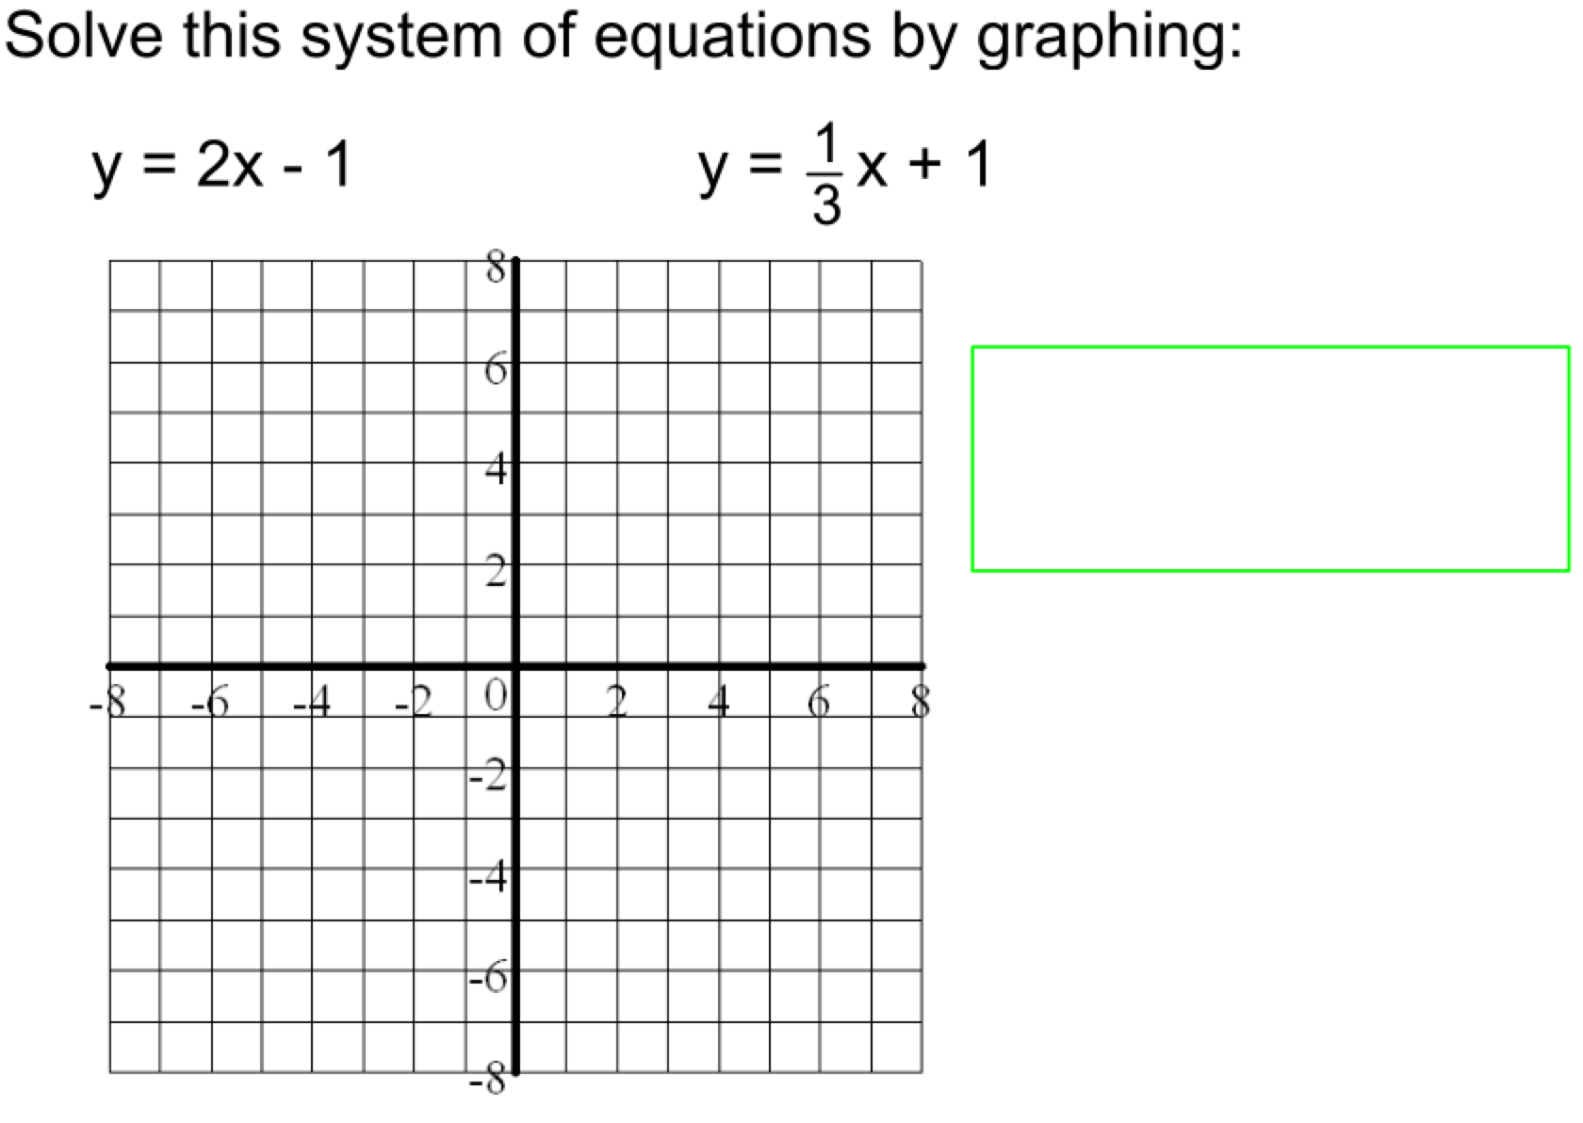

A landscaper was paid $100 for materials then $8.50 per hour to finish the flower garden.

Another landscaper worked the same number of hours and charged $140 for materials then $7.25 per hour to do another project.

Find the number of hours worked if their total bill was the same.

**Section 7.2** - Solving Systems using Substitution

* You must know what one of the variable _______________________.
* Take information from one equation and _______________________.

1.) Solve this system of equations using **SUBSTITUTION**.

_______________________

_______________________

2.) Solve.

_______________________

_______________________

3.) Solve.

_______________________

_______________________

4.) Solve.

_______________________

_______________________

5.) Solve.

_______________________

_______________________

6.) The gym teacher ordered some basketballs and some footballs. The number of basketballs is three less than twice the number of footballs. Basketballs cost $35 each and footballs cost $28 each. The gym teacher spent a total of $875.

Write and solve a system of equations to find the number of each kind of ball that was purchased.

7.) In your piggy bank, you have only nickels and dimes. There are a total of31 coins that total $2.25

a.) Write a system of equations involving n for nickels and d for dimes.

b.) Solve this system of equations to find the number of each kind of coin.