Equations for a Line:

* Slope-Intercept Form: _______________
* Standard Form: _______________
* Point-Slope Form: _______________

**Ex 1:** A line passes through the following two points: __________

Write the equation of this line in Point-Slope Form

**Section 6-2: Slope-Intercept Form for the equation of a line**

$$y=mx+b$$

Find the slope and the y-intercept of each equation.

1. ____________________ 2. ____________________

Slope: Slope:

y-int.: y-int.:

3. ____________________ 4. ____________________

Slope: Slope:

y-int.: y-int.:

5. ____________________

Slope:

y-int.:

Writing the equation of a line in Slope-Intercept Form:

Write the equation of the line that passes through these two points in Slope-Intercept Form: _______________

**Method 1:**

First: ____________________

Second: ____________________

Third: ____________________

**Method 2:**

First: ____________________

Second: ____________________

Third: ____________________

Fourth: ____________________

Fifth: ____________________

Write the equation of the line that passes through these two points in Slope-Intercept Form: _______________

Write the equation of the line that passes through these two points in Slope-Intercept Form: _______________



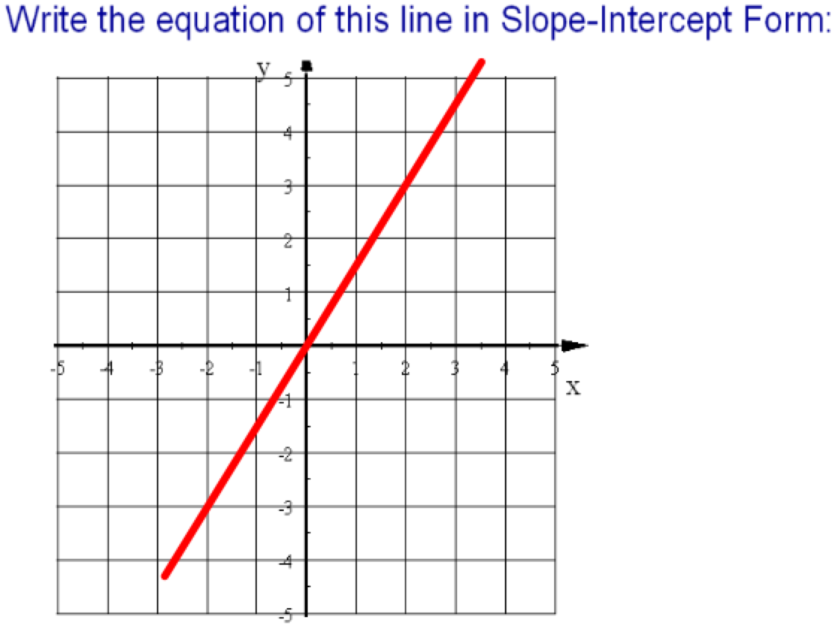



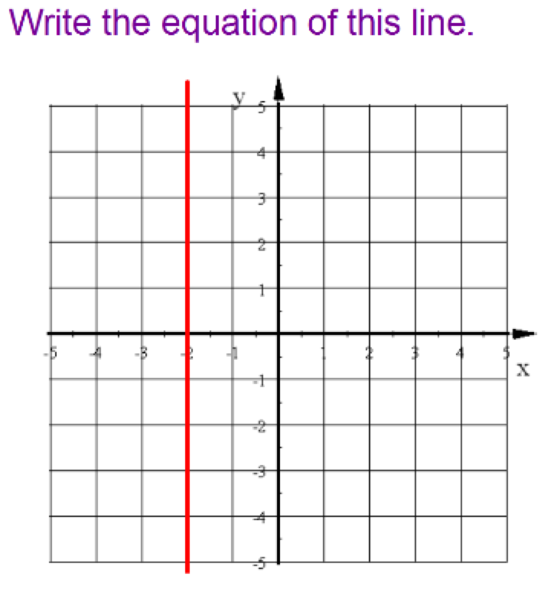

Norma won a $100 prize. Her dad put it in a savings account for her then she added $5 each week to the savings account. Model this situation with an equation.

When slope-intercept models a real situation

$$y=mx+b$$

What situation could be modeled by this situation?

$$y=12x+20$$

What situation could be modeled by this situation?

$$y=-4x+58$$