**Chapter 5 In-Class Review (Algebra I)** NAME: ____________________

State the domain and range for each graph and then tell if the graph is a function (write yes or no).

1.) Domain 2.) Domain 3.) Domain

Range Range Range

Function? Function? Function?

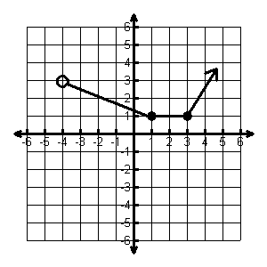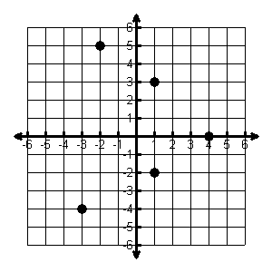

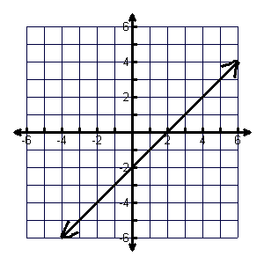

4.) Domain 5.) Domain 6.) Domain

Range Range Range

Function? Function? Function?

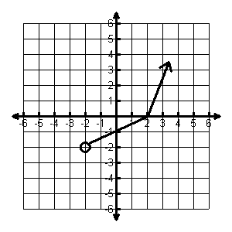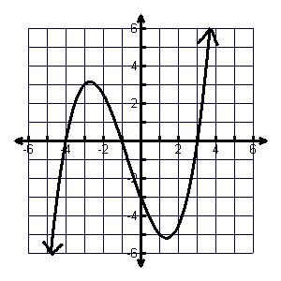

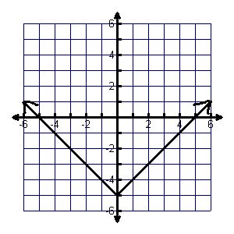

7.) Domain 8.) Domain 9.) Domain

Range Range Range

Function? Function? Function?

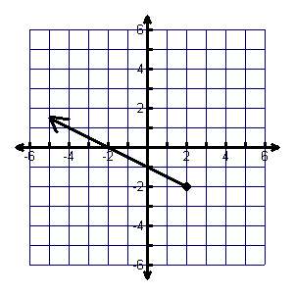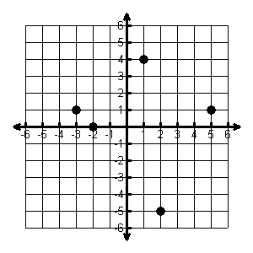

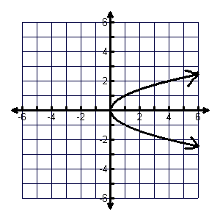

10.) A recipe for 2 dozen corn muffins calls for 3 cups of flour. The number of muffins varies directly with the amount of flour you use.

a. Write a direct variation equation for the relationship between the number of cups of flour and the number of muffins.

b. Estimate how many cups of flour are needed to make 6 dozen muffins.

11.) Your distance from lightning varies directly with the time it takes you to hear thunder. If you hear thunder 10 seconds after you see the lightning, you are about 2 miles from the lightning.

a. Write a direct variation equation for the relationship between time and distance.

b. Estimate how many seconds it would take for the thunder to travel a distance of 4 miles.

12.) Do the following graphs represent a direct variation?

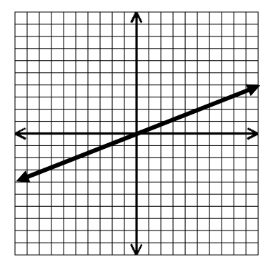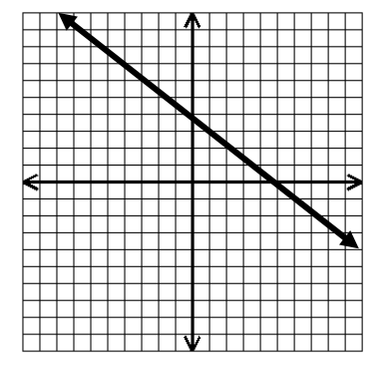

a. b.

13.) Which equation is not an example of direct variation?

A) $y=-\frac{7}{3}x+1$ B) $y=\frac{5}{16}x$ C) $y=4x$ D) $y=-9x$

14.) Which equation is not an example of direct variation?

A) $y=x$ B) $2x+3y=0$ C) $y=\frac{1}{2}x$ D) $5x+6y=30$

15.) Given the domain. Find the range of each function.

a.  b. 

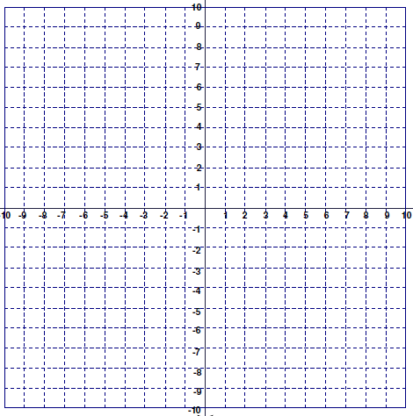16.) Graph 

**Domain (-2, -1, 0, 1, 2)**

|  |  |  |  |
| --- | --- | --- | --- |
| x |  | Y | (x, y) |
|  |  |  |  |
|  |  |  |  |
|  |  |  |  |
|  |  |  |  |
|  |  |  |  |

Where does this graph cross the y axis? ______________



17.) Graph 

**Domain (-2, -1, 0, 1, 2)**

|  |  |  |  |
| --- | --- | --- | --- |
| x |  | Y | (x, y) |
|  |  |  |  |
|  |  |  |  |
|  |  |  |  |
|  |  |  |  |
|  |  |  |  |

Where does this graph cross the y axis? ______________

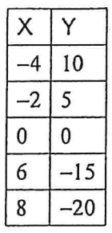

18.) Given $f\left(x\right)=2p-5$ and $g\left(x\right)=y+6$ 19.) Write a function rule for this table.

a. Find $10f\left(4\right)+2g(3)$

b. If $f\left(x\right)=40$, find $x$.