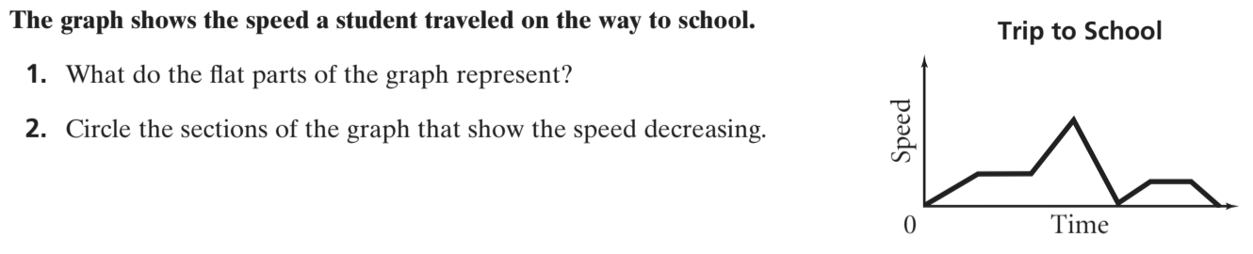

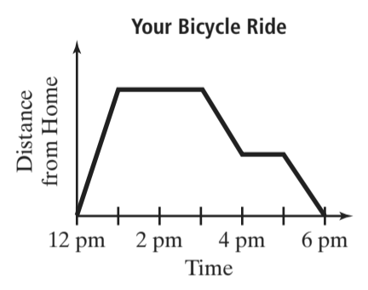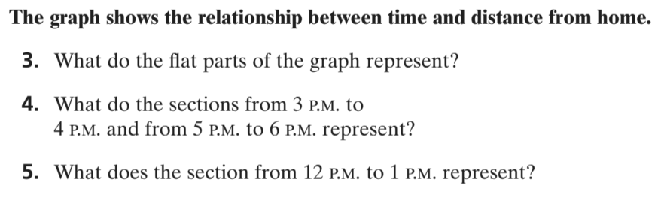



**6.** The speed of a person driving to the store and having to stop

at two stoplights.