**Chapter 3 Review**

**Write an inequality for the following statements.**

1.) The theater can seat no more than 500 people.

2.) The ladder can reach a maximum of 20 feet up the wall.

3.) They need at least 51% of the people to vote yes for the proposal to pass.

4.) The team can have up to 18 players on the roster.

5.) The minimum charge allowed to be able to use a credit card is $10.

6.) **Graph this inequality: $-4≤G$**

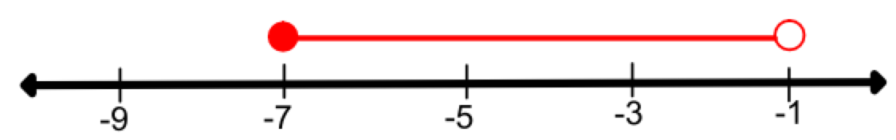7.) **Write an inequality for the following graph.**

**Solve each inequality/absolute value equation.**

8.) $4-3\left(y-5\right)+9y>15+6y$

9.) $\frac{11}{9}-\frac{7}{6}M<\frac{5}{12}$

10.) $3\left|2x-7\right|+4=31$

11.) $\frac{1}{2}\left|3x+8\right|+13=5$