1.) Madison leaves her house and bikes north at a constant speed of 10 miles per hour. If her dad leaves the same house two hours later, driving north at a constant speed of 15 miles per hour, how long will it take him, in hours to reach Madison?

A) 2

B) 3

C) 4

D) 5

2.) If the sum of two consecutive integers is 15, what is their product?

A) 36

B) 48

C) 56

D) 64

3.) Which of the following is the sum of 3 consecutive odd integers?

A) 23

B) 26

C) 105

D) 209

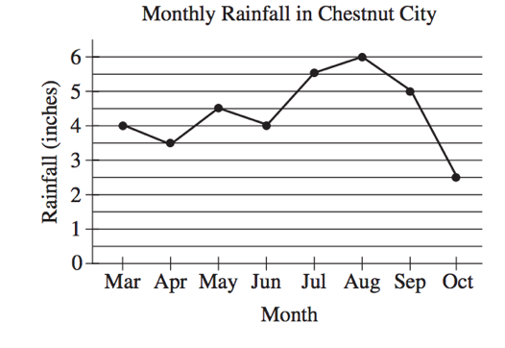

4.)

The line graph shows the monthly rainfall from March to October last year in Chestnut City. According to the graph, what was the greatest change (in absolute value) in the monthly rainfall between two consecutive months?

A) 1.5 inches

B) 2.0 inches

C) 2.5 inches

D) 3.5 inches

5.) A grocery store sells a brand of juice in individual bottles and in packs of 6 bottles. On a certain day, the store sold a total of 281 bottles of the brand of juice, of which 29 were sold as individual bottles. Which equation shows the number of packs of bottles, $p$, sold that day?

A) $p=\frac{281-29}{6}$

B) $p=\frac{281+29}{6}$

C) $p=\frac{281}{6}-29$

D) $p=\frac{281}{6}+29$

6.) Which value of $x$ makes the equation $\frac{2}{3}\left(x-1\right)=12$ true?

A) 7

B) 9

C) 17

D) 19

7.) What is the value of $h$ in the equation below?

$$\frac{2}{3}\left(3h\right)-\frac{5}{2}\left(h-1\right)=-\frac{1}{3}\left(\frac{3}{2}h\right)+8$$

A) $h=-5.5$

B) $h=5.5$

C) There is no value for $h$ for which the equation is true.

D) There are infinitely many values for $h$ for which the equation is true.