1.) A rectangle has perimeter $P$, length $l$, and width $w$. 2.) Tyra subscribes to an online gaming service that
Which of the following represents $l$ in terms of $P$ and $w?$ charges a monthly fee of $5.00 and $0.25 per hour for
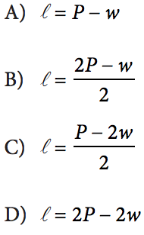
time spent playing premium games. Which of the following functions gives Tyra’s cost, in dollars, for a month in which she spends $x$ hours playing premium games?
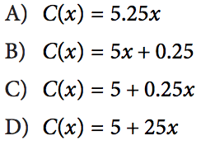

3.) A soda company is filling bottles of soda from a tank that
contains 500 gallons of soda. At most, how many 20-ounce
bottles can be filled from the tank? (1 gallon = 128 ounces)

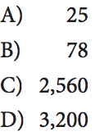

Algebra I – Bellwork #23 (PSAT Practice) Date: __________

1.) A rectangle has perimeter $P$, length $l$, and width $w$. 2.) Tyra subscribes to an online gaming service that
Which of the following represents $l$ in terms of $P$ and $w?$ charges a monthly fee of $5.00 and $0.25 per hour for
time spent playing premium games. Which of the following functions gives Tyra’s cost, in dollars, for a month in which she spends $x$ hours playing premium games?

3.) A soda company is filling bottles of soda from a tank that
contains 500 gallons of soda. At most, how many 20-ounce
bottles can be filled from the tank? (1 gallon = 128 ounces)

