Solve each equation.

1.) $5+\frac{c}{3}=9$ 2.) $\frac{m+1}{6}=9$

3.) $\frac{11m}{4}=8$

4.) The measure of $∠A$ equals the measure of $∠B$. Write and solve an equation to find the value of x.

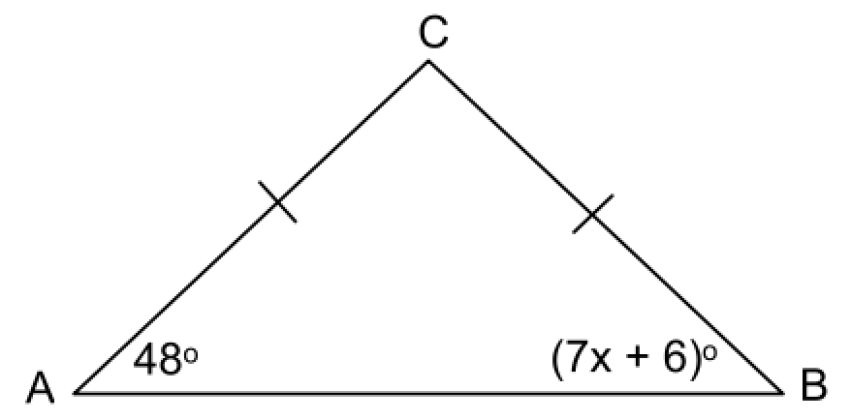

**Algebra I – Bellwork #12 Date: __________**

Solve each equation.

1.) $5+\frac{c}{3}=9$ 2.) $\frac{m+1}{6}=9$

3.) $\frac{11m}{4}=8$

4.) The measure of $∠A$ equals the measure of $∠B$. Write and solve an equation to find the value of x.

