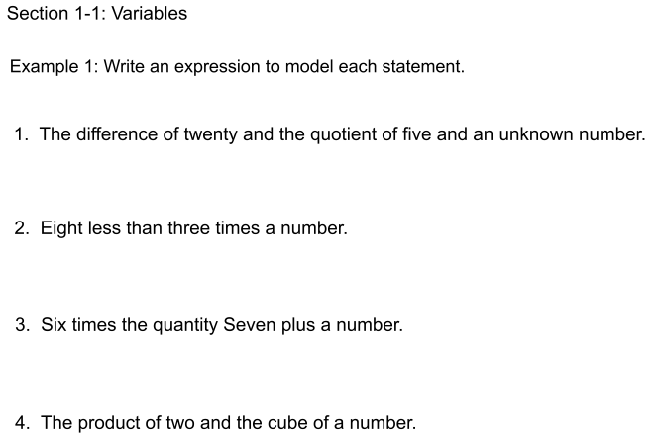

Example 2: Track One Media sells all CDs for $12 each. Write an equation for the

total cost of a given number of CDs.

Relate: The total cost is ___________ the number of CDs bought.

Define: Let n =

Let c =

Write:

Your Turn: The perimeter of a square equals 4 times the length of a side.

EQ: Variables:

Your Turn: You have 20 dollars more than me. Write an equation to find out how much money we both have.

EQ: Variables:

Your Turn: The amount of money you would have spent at the store if you bought some cans of pop for $1.5 each and some bags of chips for $2 each.

EQ: Variables:

