**Algebra I – Section 6.2 Guided Notes Cont…**

**Review IXL S.4**

1.) A line has a slope of 8 and includes the points (-9, 0) and (-8, z). What is the value of z?

2.) A line that includes the points (-3, -6) and (2, u) has a slope of -8. What is the value of u?

**Section 6-2: Slope-Intercept Form for the equation of a line**

$$y=mx+b$$

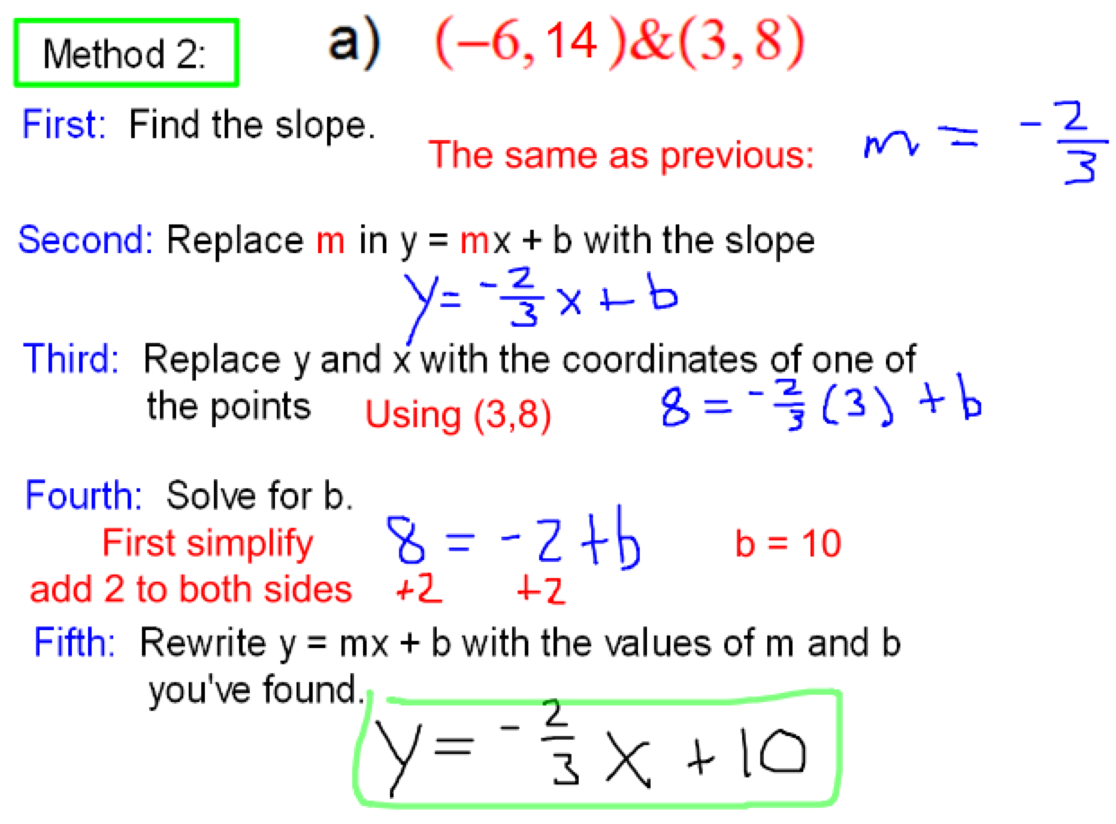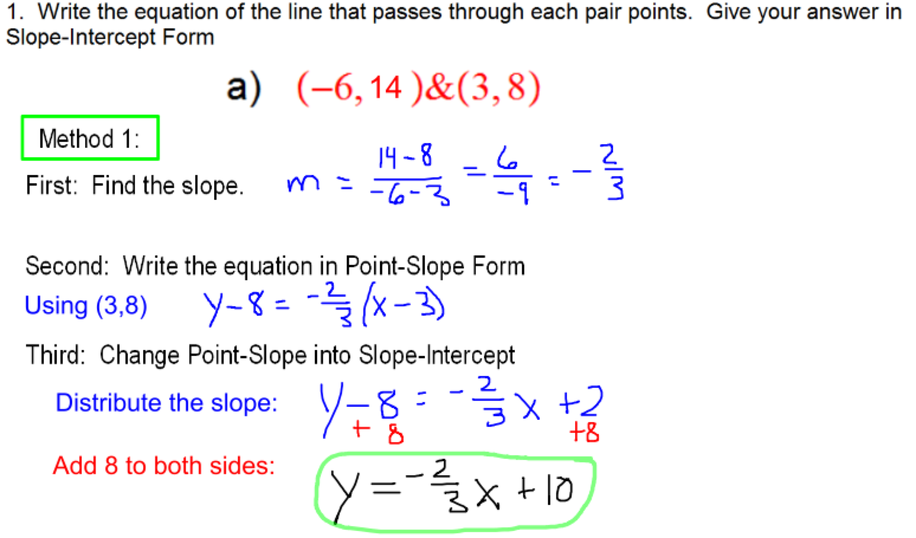

1.) Write the equation of the line in Slope-Intercept Form that passes through this pair of points: ____________________

2.) Write the equation of the line in Slope-Intercept Form that passes through this pair of points: ____________________

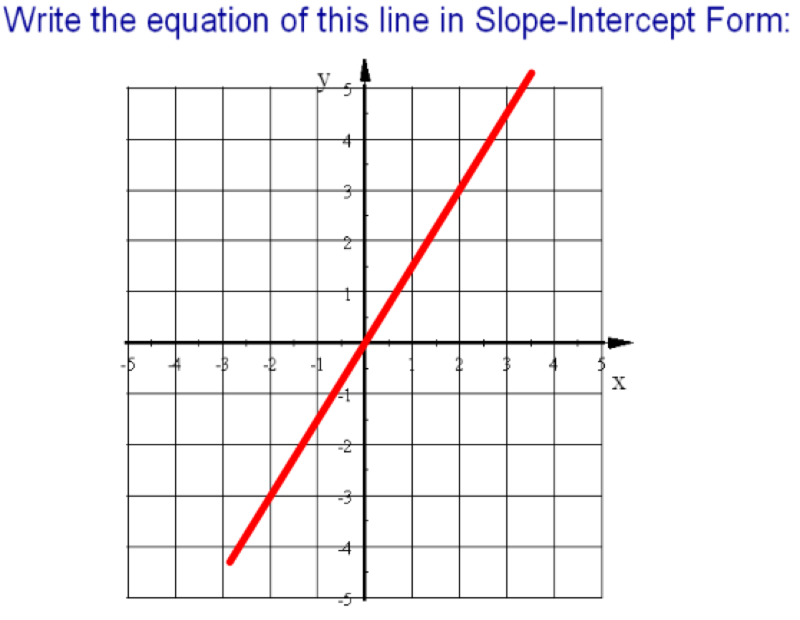

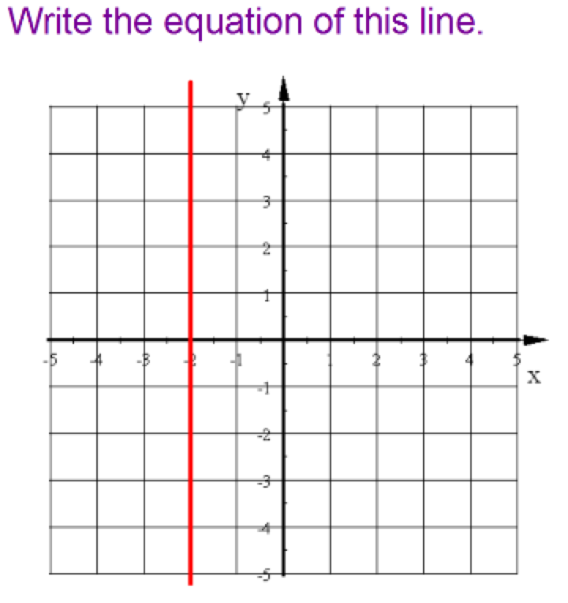

Find the y-intercept and x-intercept of this line:

y = 2x + 3

Find the slope and y-intercept of each line:

1.) 2.)

Write an equation to model each situation.

1.) You have 75 songs on your i-pod right now and plan to download 4 more each week.

2.) At the ballgame, you bought 3 hot dogs and 4 Cokes for $25.25.