**Algebra I – Slope Intercept Form Name: ____________________**

**Homework #41**

**Find the slope of each line. Then write the equation of each line in slope-intercept form.**

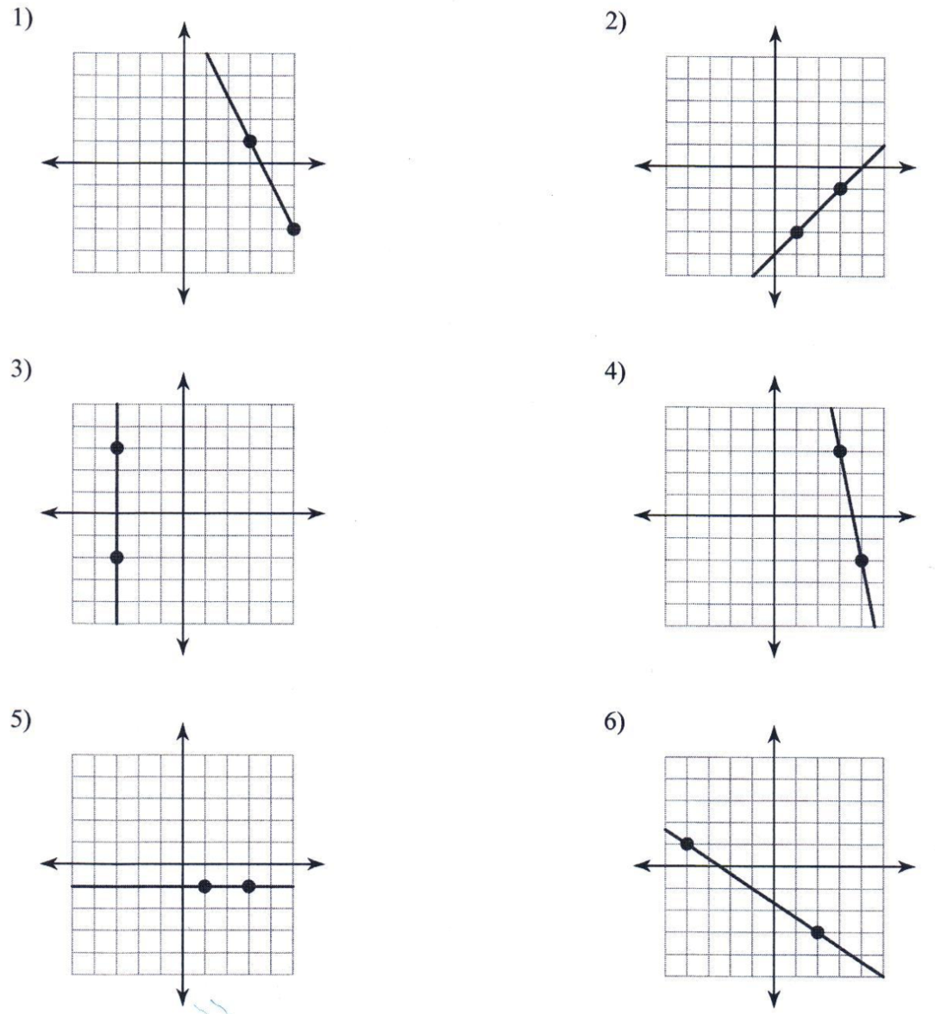

**Find the slope of the line that passes through the pair of points. Then develop an equation in slope intercept form of the line.**

7) (-5, 0) and (-4, 4) 8) (-2, -1) and (-4, -3)

9) (-4, 3) and (-5, -2) 10) (5, -5) and (0, -1)