**Bellwork #58 – Algebra I Date: __________**

**Find the slope of each line. Then develop an equation in slope-intercept form.**

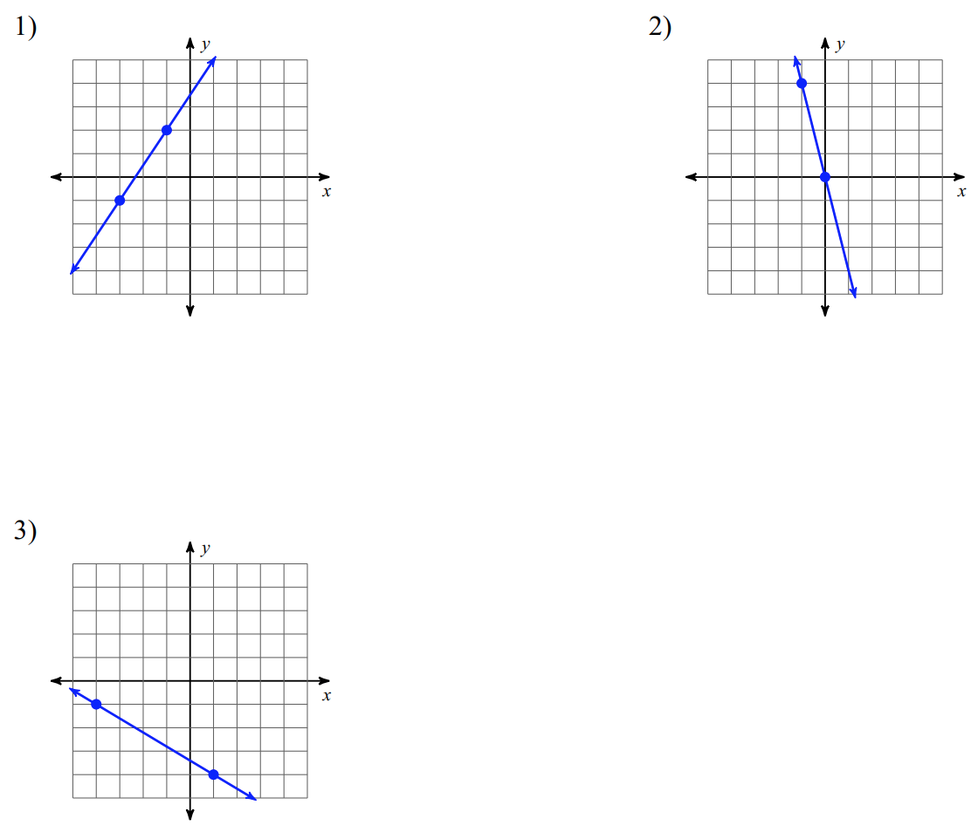

**Find the slope of the line that passes through each pair of points. Then write the equation of the line in slope-intercept form.**

4) (-3, -2) and (-4, 3) 5) (-3, 1) and (0, -4)

6) (0, -4) and (3, 5) 7) (-1, -2) and (-3, 2)