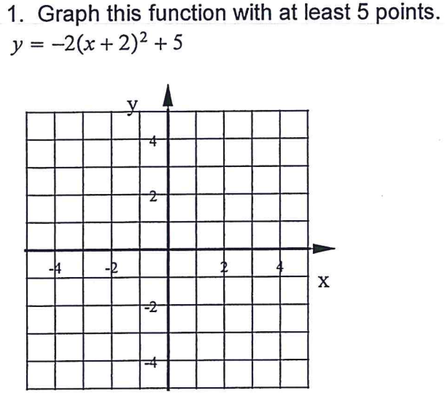

/Users/husseinhussein/Desktop/Screen Shot 2017-12-11 at 11.44.08 AM.png

2.

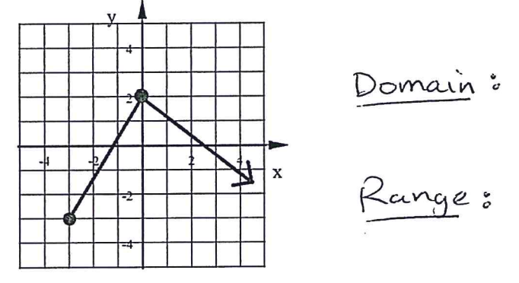

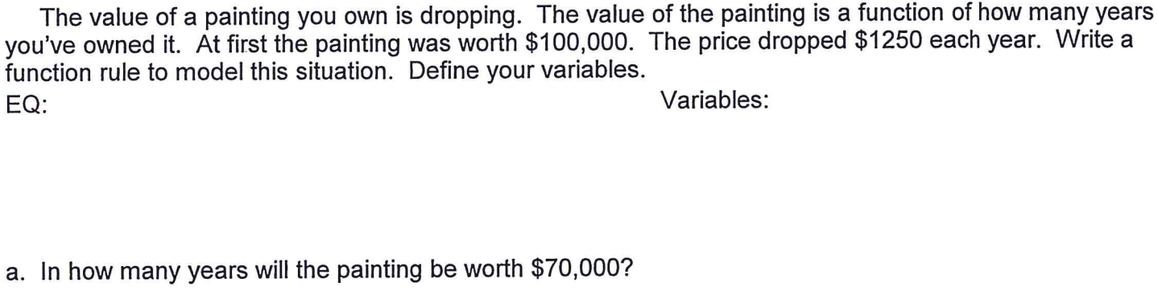

3.



4.